**Developing an android application teaching students to program with the use of gamification**

**as an incentive**

**Supervisor**: Mariusz Pelc

April 2016

**Word count:**

**13237**

A dissertation submitted in partial fulfilment of the University of Greenwich’s

**BSc Hons Computer Science**

**Abstract**

Many educational applications on the market do not make use of the gamification techniques. Some people can learn visually and some people can learn with audibility, and some can learn with virtual interactivity.

This report will explore how the ways and motivation can help people learn better with the use of gamification techniques in order to create an android gaming app as a stimulus.

**Acknowledgements**

I would like to take this opportunity to thank the people that have helped, assisted and supported me with this project throughout the course of this project.

-My supervisor, Mariusz Pelc, for supporting me during the project and providing me feedback in relation to the product and report.

-My second marker, Georgia Sakellari, for also supporting me during the project and providing me valuable feedback in relation to the product and report.

-My friends and family for supporting me throughout the project duration and kept on pushing me forward, in order to do good.

-The YouTube channel, JoeRock, for assisting me with the development of the Android application, to which I couldn’t have made without his assistance.

-Last of all, the community at Stack Overflow forum for all the help given and allowing me to have a better understanding of Android app development.

**Table of Contents**

1 Introduction 10

1.1 Background Information 10

1.2 Scope of the Project 10

1.3 Aim and Objectives 10

1.4 Approach 11

2 Literature Review 11

2.1 Introduction 12

2.2 The Use of Gamification Techniques 12

2.3 The Issues of Gamification 13

2.4 Intrinsic and Extrinsic Motivations 13

2.5 The Ways of Learning 14

2.6 Gamification in Learning 15

2.7 Conclusion 15

3 Technical Review 16

3.1 Technical Considerations and Decision 16

3.2 Shared Preferences 18

3.3 Confidentiality of Data Storage 19

3.4 Avoiding SQL Injection 19

3.5 Legal, Social, Ethical and Professional Issues and Considerations 19

4 Critical Review of Existing Products 21

4.1 Similar Products Available 21

4.2 Evaluation Techniques 21

4.2.1 Nielsen’s Heuristics 22

4.3 Evaluation of Existing Products 23

4.3.1 Learn Programming with Swift 23

4.3.2 Programming Hub 23

4.3.3 Nike + Fuel 24

4.3.4 Conclusion 24

5 Design Documentation 24

5.1 Extrinsic Rewards 24

5.2 Statement of Requirements 25

5.2.1 Functional requirements 25

5.2.2 Non-functional requirements 25

5.2.3 Additional Requirements Based on Literature Review 26

5.3 UML Diagrams 26

5.3.1 Use Case Diagram 26

5.3.2 Sequence Diagram 28

5.4 ER Model Database Schema 29

5.4.1 Conceptual Data Model 29

5.4.2 Logical Data Model 30

5.4.3 Physical Data Model 31

5.5 User Interface Design 32

5.5.1 Wireframes 32

5.6 Colour Scheme and Font Decisions 37

5.7 Pseudocode for Algorithms Used in Android Application 38

6 Implementation 38

6.1 Frameworks Required and Used in the Application 38

6.2 Android Application 39

6.2.1 Prototype One 39

6.2.2 Prototype Two 40

6.2.3 Prototype Three 40

6.2.4 Prototype Four 40

6.3 PHP Web Service 41

6.4 MySQL Database 41

6.5 The option of New Game Plus 42

6.6 Sample of Android Codes 42

7 Testing Documentation 42

7.1 Testing Strategy 42

7.2 Android Application 43

7.2.1 Prototype One 43

7.2.2 Prototype Two 43

7.2.3 Prototype Three 43

7.2.4 Prototype Four 43

7.3 PHP Web Service/ MySQL Database 43

8 Evaluation 44

8.1 Nielsen’s Heuristic Evaluation of the Product 44

8.2 Statement of Requirements Evaluation 46

8.3 Focus Group Evaluation of Product 46

8.4 Future Updates 47

9 Conclusion 48

9.1 Review of Project Process 48

9.2 Critical Evaluation of Product 48

9.3 Critical Evaluation of Personal Performance 49

10 References 50

11 Appendices 52

11.1 Appendix A - Existing Product Reviews Evaluation 52

11.2 Appendix B – Screenshots of working program 57

11.3 Appendix C – Sample of SQL Statements used in PHP 67

11.4 Appendix D - Sample of Android Codes 69

11.5 Appendix E –Android Application Test Plan 72

11.6 Appendix F- PHP Web Service/ MySQL Database Test Plan 79

11.7 Appendix G - Statement of Requirements Evaluation 81

11.8 Appendix H - Project Proposal 84

**List of Figures**

*Figure 1 Architecture of code-sharing(PCL and Shared Asset Project) _______________________________________ 15*

*Figure 2 Use Case Diagram For Android Application ____________________________________________________ 24*

*Figure 3 Use case diagram For PHP Web Service _______________________________________________________ 25*

*Figure 4 Sequence Diagram for Start Learning Use Case _________________________________________________ 26*

*Figure 5 Conceptual Data Model ___________________________________________________________________ 27*

*Figure 6 Logical Data Model _______________________________________________________________________ 28*

*Figure 7 Physical Data Model ______________________________________________________________________ 29*

*Figure 8 Wireframe One - Menu Page _______________________________________________________________ 30*

*Figure 9 Wireframe Two - Browsing Chapters/ Topics ___________________________________________________ 31*

*Figure 10 Wireframe Three - Game Page _____________________________________________________________ 32*

*Figure 11 Wireframe Four – Leader board Page _______________________________________________________ 33*

*Figure 12 Wireframe Five – Achievements/ Badges Page ________________________________________________ 34*

*Figure 13 A example of the Picasso Framework being used in the application ________________________________ 36*

# 1 Introduction

## 1.1 Background Information

Many educational applications on the market do not make use of the gamification techniques that are available. Some people can learn visually and some people can learn with audibility, and some can learn with virtual interactivity. This project will explore how the ways and motivation can help people learn better with the use of gamification techniques in order to create an android gaming app as a stimulus. At the moment, there are few apps in the PlayStore which offer an insight into learning programming with little or no gamification techniques involved. The few current apps in the stores may have gamification in them, but the apps themselves are not fully open source. To solve this, an app needs to be created in order to challenge the existing ones and improve further so it exceeds the current ones in creativity and productivity.

## 1.2 Scope of the Project

The purpose of this project is to develop an open-source Android application that will have gamification techniques implemented in order to make the users learn more about programming. There will be various topics to tackle e.g. choosing the correct ‘For Loop’ with a given scenario, in order to keep the users engaged and not become bored of just playing a static game. Gamification techniques such as achievements, levels, badges, etc. will be a big feature of this application, as this will help the users to be occupied. The score that is obtained from the rush mode (different game mode to normal mode) can be posted to social networking such as Facebook to show to their friends/followers. In doing so, this app could be promoted to other users and they can see what it is all about.

The end product will be developed on Android using Xamarin Studio. The reason why it is being developed on an Android platform and not cross platform is because initial searches indicated that Android market had a gap in this field of research.

## 1.3 Aim and Objectives

The aim of this project is to explore the ways on how gamification can be a motivation for learning in order to create an Android mobile gaming application that will allow users to learn how to program in C#.

For a full list of the objectives that were created at the beginning of the project, please refer to Appendix H.

A summary of the objectives is shown below:

* Conduct and compile a literature, technical and existing product review
* Produce a design documentation with all of the necessary information such UML diagrams, statement of requirements etc.
* Implement the product according to the design document
* Test the implemented product thoroughly for any bugs
* Evaluate the product and personal performance

## 1.4 Approach

A methodology must be chosen when carrying out a project in relation to IT. Following a methodology will ensure the success of the project as well as being cautious in the stages of the development. For this particular project, the iterative methodology was selected over other methodologies due to having many benefits. The methodology allows the project to be broken down into a series of smaller projects, where each can be planned and delivered individually.

This method also allows the probability of revisiting any stages in the development cycle in light of new information. For example, if the designer feels the algorithm being implemented is not correct, they would revisit the design stage and fix the algorithm before moving forward with the implementation. The problem would arise only when the previous stages are visited many times back and forth and thus having an effect on the limited time that is allocated. Even though this methodology allows the visitation of previous stages, it is crucial to avoid the need to visit various times to ensure the maximum time and effort is used in each stage effectively.

# 2 Literature Review

The purpose of this literature review is to investigate the areas of relevance to gamification and learning. From this, this literature review will focus on how gamification can be used in education to enhance the motivation in learning and what benefits and drawbacks could arise when they are associated together.

## 2.1 Introduction

During the past couple of years, gamification appears to be a trending theme and a subject of much hype as a means of engaging participants in activities they discover to be entertaining in order to influence their behaviour. According to (Zichermann and Cunningham, 2011) the term gamification refers to the usage of game design components in non game contexts, in other words, it is the notion of applying game mechanics and game design techniques to allow people to be engaged, motivated and solve problems in order to achieve their goals, and not the goal of the organization. In a study constructed by Jakubowski (2014) the gamification term was first devised in 2002 by Nick Pelling, however, it did not gain recognition as it was too early for the concept to be adopted into the real world until the second half of 2010 where it started to become used worldwide in several sectors such as business, health and education.

## 2.2 The Use of Gamification Techniques

Some may think gamification is the process of just making activities look like a video game and keeping users interested through this medium, but this is not true. The real purpose of gamification is not ideally to make a game, but it is to take what makes games so appealing and implement them into other activities. It is usually best to implement gamification into the non-game activities that offer too little content to stay interested, so the task to be completed would be changed into some form of game experience in order to define the objectives and rules of the game according to Laskowski (2015). An example of a gamification being used is the piano stairs, where it was installed in Odenplan metro station in Stockholm to encourage customers to avoid using escalators and use the piano stairs in order to reduce the congestion during the rush hours. Installing the piano mechanisms on the stairs was the designer’s choice of changing people’s behaviour and inspiring them to choose the stairs instead of the escalator with the former benefiting the customers in terms of health wise (Peeters *et al*, 2013). According to a figure released by Volkswagen (2009), 66% more people have decided they would use the stairs rather than the escalator. In relation to gamification, it clearly shows how much a simple technology can persuade people, to change an attitude or behaviour. Likewise, when trying to implement gamification into an activity, it is necessary to understand the target audience’s attitude and behaviour so the gamification techniques can be planned on these two factors.

Furthermore, Zichermann and Cunningham mentioned that gamification can fix complex and large scale problems, however, this does not mean the activities have to be large scale and complexity to prove the point. Even a simple activity that awards players with points, achievements is equally amusing and rewarding and sometimes more effective than complex activity. A very interesting article by Laskowski (2013) states that when trying to implement gamification technique, there are various specifications that are needed to be taken into consideration – such as setting objectives and game goals, adding value to ensure users feel they have accomplished something, having an in-game leader board which awards users for their commitments in playing, a list of achievements such as badges or titles earned by the users during the user’s play through, influencing others by both co-operation and rivalry by building sharing loops (sharing achievements on social networks, fighting for the top spot on the leader board), a progress statistics which shows the progress of the user within a game and the implementation of quick rewards - in order for it to be considered successful, otherwise gamification will not work. The gamification techniques are there so it can be a way to engage people to leverage their natural instinct of desires and it is imperative to consider what gamification techniques will work and what will not work when trying to implement.

## 2.3 The Issues of Gamification

When gamifying any activities, whether it be a classroom learning, an application, a business meeting, etc., it is fundamental to remember the audience and how they will be able to relate to such gamification techniques being introduced. Before gamifying any activities, it is important to plan carefully beforehand thoroughly. According to Hamari *et al* (2014), if the gamification techniques such as leader boards, levels, etc. were integrated into the non-game activities without setting an objective or understanding how it connects with the user, gamification will not work, no matter how hard anyone tries. The piano stairs may have been successful, but it is essential to consider the alternate events that may take place. Laskowski mentioned it is important to consider the alternate events for the piano stairs as there may be some people that might get frustrated with the noise level on the staircase during rush hours or even when there are few people walking the stairs. The mutualistic footsteps on the staircase may turn the pleasant situation into an unpleasing experience, and may disturb people. So it is always important to understand the different types of people that may be in favour or against this and come up with solutions to please both types.

Gartner (2012) had estimated that by 2014, 80% of current gamified applications will fail to meet business objectives due to poor design and poor implementation of the gamification techniques. Even applying basic game mechanics such as points, badges and leader boards for no actual purpose or no relation to the activity whatsoever will also fail. If the gamification is poorly implemented, there could be higher chance the activity might have an opposite effect such as demotivation and turning routine events into mundane or even chores.

## 2.4 Intrinsic and Extrinsic Motivations

Anyone to be motivated would mean they are energized towards an activity, otherwise if they have no inspiration they are categorized as unmotivated. Breaking down the word motivation into two parts: intrinsic motivation and extrinsic motivation, could further define the characteristics of a person. Saying a person is intrinsically motivated would mean the motivation would come from within, not external sources and the person are moved to act for the amusement or trials involved, whereas an extrinsically motivated person would wait for an activity to end in order to be rewarded with an independent outcome.

Intrinsic motivation would result in internal rewards such as positive feelings and amusement whereas extrinsic motivation results in doing something for external rewards such as praise, money or fame (Ryan and Deci, 2000). In summary, intrinsically motivated people tend to have a desire for the activity itself while extrinsically motivated people tend to to have a desire for the outcome of the activity, ignoring the processes in between.

Zichermann and Cunningham states that the two types of human motivation: intrinsic and extrinsic can drive player’s behaviours. In order to support this, Edward Deci constructed an experiment to test the intrinsic and extrinsic motivations where he asked two groups to participate in playing a game called Soma. The difference between the two groups playing the game was that group A was paid for each puzzle solved whilst the other group, B, played for no financial reward. The results obtained from this experiment, Deci found out that when there was no more money to be had in the game, group A stopped completing the puzzles. On the other hand, group B kept on playing and solving puzzles even though the experiment had finished. From this, Deci concluded that the reason why group B was still playing is because of being intrinsically motivated in solving the puzzles, and the reason why group A stopped playing is because of their intrinsic motivation being reduced by their extrinsic reward. It can be said then that intrinsic and extrinsic motivations are codependent on each other in some way, rather than being independent of each other.

## 2.5 The Ways of Learning

Learning is the key fundamental process that everyone needs to endure in their lifetime and it happens quite naturally. Without it, people will not be able to adapt and bear with the surroundings. Learning is a tool that can be used to achieve a person's full potential and it does not happen through isolation, and there are many factors that can either boost learning or hinder learning. A person's motivation and their preferred learning style can be a help to their ability to learn (Pritchard, 2014).

There are many ways that any individual can process their learning capabilities due to their individual learning preferences. It is the notion that every individual learner has their own style of preferred learning, and how they process it or not process it is up to the stimuli they are being confronted with. For example, one learner might be taking in information with ease through a particular medium, whereas another learner might find it difficult. This differentiation leads to a classification of learning types to which it labels learners such as visual, auditory, reading/writing and kinaesthetic learners.

Visual learners learn by seeing and visualizing the content. They tend to understand and remember by graphics as they mentally picture what they are learning. Auditory learners learn from having things verbally being explained to them rather than to read orally. They understand and remember things they have heard as they have stored information in their mind as to how it sounds. According to an experiment conducted by Baddeley *et al.* (1975), repeating certain words for more than 20 seconds up to a minute would store the information in the long term memory, where anything under 20 seconds give or take two will store it in the short term memory to which the information would last for a couple of minutes and then will be forgotten. So aural learners tend to use repetition as a study technique to store information in their long term memory. Reading/writing learners learn best through words and may present themselves as copious note takers or passionate readers as they prefer information to be displayed in writing. Kinaesthetic learners learn through the use of tactile representations of information, meaning they learn by doing and solving real life problems, i.e. understanding how a clock works by fitting one together. They tend to take hands-on approaches to things and learn through trial and error.

## 2.6 Gamification in Learning

According to Gartner, gamification is increasingly being used in formal education to engage students in a more immersive learning experience. There are many approaches to engage students, and they can generally be split into two categories: building a game layer on top of the lesson material or turning the lesson into a game.

When trying to mix gamification and learning together, it is pretty clear that the whole purpose is to get the players to be intrinsically motivated by using extrinsic rewards. An article by Jayasinghe and Dharmaratne (2013) states that the old teaching style is no longer favourable to the students. The students cannot take in so much information at once and cannot undertake any practical exercises under the old style. The students should be understanding the fundamental concepts of the subject matters instead they focus on the exams. In order for students to learn by experience, a concept has been put in place called edutainment (a mix of education and entertainment) where it heavily uses gamification applications. This allows the students to drop their ‘learning by studying and imagine what would happen’ style and have an opportunity to explore and make observations in an imaginary world to gain results in such experiments.

While the concept of gamifying any activities may be simple and should be properly implemented to avoid any issues arising, but effectively gamifying it for an educational purpose may be complex. Nevertheless, the concept can be simplified if the following steps are taken into considerations. The target audience is identified and researched upon to fully understand what it is required, defining the learning objective to ensure the user is aware what to achieve, carefully constructing the experience by including extrinsic motivational elements in order to apply intrinsic motivation to the user, identifying the resources needed to gamify the application and finally choosing the correct gamification elements to be applied.

## 2.7 Conclusion

Within the ‘Use of Gamification Techniques’ section of the literature review, the discussion was how the gamification techniques can be used in activities to turn the situation around and encourage users to take part in and. The piano stairs are a good example, as it encouraged people to take the stairs to reduce the congestion during rush hours, benefitting the social and environmental aspect. Laskowski explained really well the various specifications that are needed to be taken into considerations. For this project, these considerations will be acknowledged and adhered to to ensure the success of the product.

Within the ‘Issues of Gamification’ section of the literature review, poor implementation of gamification will not work and may have negative effects on the user. Even Hamari *et al* thought that gamifying an activity should have a purpose as to why it is being implemented with set objectives and it should connect with the intended audience, otherwise gamification would not work. For this project, it is crucial to understand and connect with the target audience and have gamification techniques that are well implemented.

Within the ‘Intrinsic and Extrinsic Motivations’ section of the literature review, it was stated that the use of extrinsic motivational elements should be used in gamification to encourage the users to have intrinsic motivation as Deci has proved with his experiment that they are both co-dependent to each other, rather than being independent. Also taking points from Deci’s experiments, when it comes to gamification the extrinsic rewards are already covered. However, for gamification to truly motivate players, it has to correctly target those audiences that have intrinsic motivated behaviours otherwise gamification will fail. So this project will implement extrinsic rewards and cater those rewards for the target audience.

Within the ‘The Ways of Learning’ section of the literature review, there are four learning types and each type can describe a person on how they learn. When carrying out this project, the visual, auditory and reading/writing styles of learning must be looked upon. Kinaesthetic style was omitted as it would be impossible considering this project is an application.

Within the ‘Gamification in Learning’ section of the literature review, Jayasinghe and Dharmaratne expressed that learning by studying has become an old mechanism and learning by experience is the way forward. In addition, the concept of gamifying an educational activity must take the steps mentioned. This will ensure the gamification has been implemented successfully. For this project, it will need to take into consideration the ‘learning from experience’ style and the gamifying of the application by following the steps.

# 3 Technical Review

The purpose of this technical review is to discuss the considerations and decisions of the technical tools that could be used in this project.

## 3.1 Technical Considerations and Decision

The Android application will be the front end of the system as this is the only interface that the users would be able to see. The web client will be acting as a middleware to ensure it provides a response by communicating with a web server (mainly PHP) in order to receive and transfer data. The database will act as the back end of the system as this will hold the necessary information, such as achievements, badges, user progress etc. in relation to the application. Mock data will be used during the development phase to ensure the functionalities of the app is in high standard.

‘Xamarin Studio’ will be chosen as the development studio to create the Android app over other development programs such as ‘Eclipse’, ‘Android Studio’, ‘NetBeans’ etc. The Xamarin Studio also allows the implementation of web clients; in which it would therefore reduce the need of using another development studio. In doing this, it would allow the application and the web clients to be implemented back and forth.

The reason why Android Studio, Eclipse or NetBeans will not be chosen as the primary development studios is due to the development language that is being used in each IDE’s. Since this project is focusing on educating people how to us C# with gamification, it would make sense to choose a development studio that is also coded in C#. In this case, the Android Studio doesn’t offer the option to code in C# as the primary/secondary language, the only option is to code in Java. Nevertheless, the Eclipse and NetBeans offers the option to code in C# but a plug-in has to be downloaded and installed first. Even installing plug-ins into the IDE’s when there is Xamarin Studio that handles Android application in C# would not be a smart move to do. In addition, personal experience in coding is mandatory to consider during the pre-development stage as this may have a huge impact when it comes to actually implementing the application. Having a strong knowledge of C# compared to Java, it would be better to carry out the implementation in Xamarin Studio IDE, however, if the Java knowledge is stronger than C# then it would a wise choice to choose either Android Studio, Eclipse or NetBeans.

Xamarin Studio allows the possibility of developing a cross platform application between Android, iOS and Windows. The logic is to use a Portable Class Library(PCL) or a Shared Asset Project where they both share the data, business, data access and service access layers between the three platforms. All the Application logic and User Interface Layer are handled in each specific platform (Figure 1). The PCL uses interfaces to provide platform-specific functionality, whereas the Shared Asset Project uses the #if compiler directives to target each specific platform requirements. Even though the project is targeting an Android platform, in the future the application can be extended to support both the iOS and Windows with the use of PCL or Shared Asset Project.

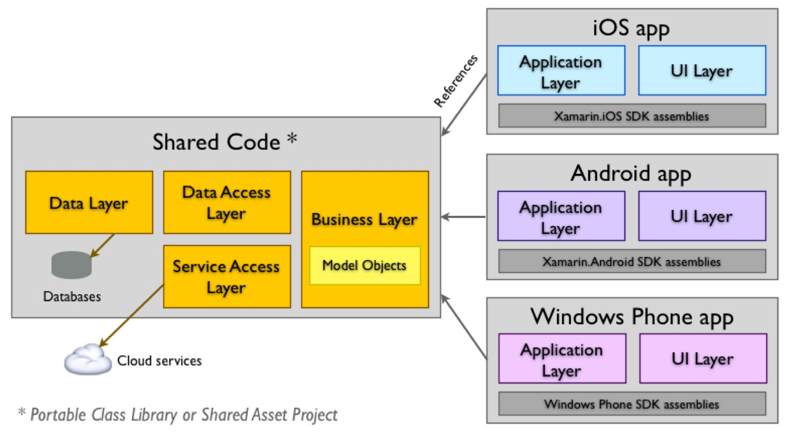

*Figure*

*1*

*Architecture of code*

*-*

*sharing*

*(*

*PCL and Shared Asset Project*

*)*

The Xamarin Android Player is an Android Emulator developed by Xamarin to ensure the fast deploying of application to the emulator compared to the stock emulator embedded in the Xamarin Studio. This will in turn help the development phase as the debugging, running and testing the application in Xamarin Android Player will execute faster, reducing the time if it was deployed to the stock emulator.

The Facebook Android SDK library, by Facebook (obtained from Xamarin Components Store), will be used in this project rather than any other third party Facebook SDK’s as it is easier and faster to integrate into an Android application. to ensure the sharing of the users score are posted on Facebook with ease.

As far as PHP is concerned, the web clients will send a request to the PHP thus allowing the PHP to contact the database. This will be used in both sending and receiving data to/from database.

For database modelling tool, the MySQL Server RDBMS has been chosen over MSSQL Server RDBMS as the developer was comfortable, accessible and experienced with the former.

## 3.2 Shared Preferences

The Shared Preferences class allows the storage and retrieval of persistent key value pairs of primitive data types. This allows data to be preserved across user sessions even when the application is killed. The Shared Preferences will be used to store the username when they first install and launch the application. Once entered, this will allow the user to avoid the need of entering the username every time when the app is launched. The username will act as an ID to each specific user and will be majorly used in PHP as part of the SQL statement in the WHERE query to insert, update and delete records in accordance to the specific user. The username will also be used to determine the leader boards, achievements progress, badges progress and user progress. Since the username will be stored in the Shared Preferences, it can only be accessed by that android device. To overcome this, the username has to be stored in the database for a global access.

## 3.3 Confidentiality of Data Storage

The integration of the Facebook SDK requires the user to sign in to their account before they are able to post anything. During and after the login phase, it must be made sure the personal account details are not stored anywhere in the application or the database otherwise this will be infringing the Data Protection Act. In addition, the users must be notified of any activities with Facebook and gain permission such as when accessing profile information, sharing contents etc. if only the application requires it.

## 3.4 Avoiding SQL Injection

To avoid any SQL injection in the Android Application, it will be better to use MySQLi prepared statements in PHP to make sure that the SQL server parses the SQL statements and generates an execution plan for the query. As security is concerned, there is no need to escape anything in the PHP files, since the parameters are bonded.

## 3.5 Legal, Social, Ethical and Professional Issues and Considerations

As far as legal issues are concerned, the first legal consideration that needs to be taken into consideration is the ‘Data Protection Act 1998’ law as it states that it has to protect personal data such as name, password, address etc. stored on computers or in an organized paper filing system. The act controls how personal information is used by organizations, businesses or the government. The law allows the people to have the right to know what information is being held about them and how their personal information is being handled. Users will be asked to sign in to their Facebook account in order to post their score to their Facebook status. For privacy purposes, any personal details should not be stored in the database to avoid any unnecessary parties gaining access. The details could be stored in the Android Shared Preference to avoid users signing in constantly when they re-open the app, and deleted from Shared Preference when necessary.

Second consideration is the ‘Copyright, Designs and Patent Act 1988’ as it was designed to protect all types of intellectual property and to ensure that the authors or creators receive the full credit and compensation. This act protects the rights of an individual or an organization from having their work being replicated or modified without their knowledge and consent. Any assets that are used in this project should be copyright free or given permission for usage from the authors/creators. As this project will primarily use open source software for the development of this project, it should not anyway be modified or sold to risk comprising this act either.

Social issues can arise if the posting of scores to the Facebook network is not handled properly, in other case if the wrong information is posted or manipulated somehow due to poor coding. In order for this to be avoided, it is necessary to take extra caution when coding to make sure the right information is being posted and shared. Another issue might be the accidental gathering of personal data when a user logs in to their social network accounts without the user’s knowledge. This should be avoided in any cost and carefully implemented to make sure only the necessary data is gathered.

The ethical aspect of this project is in regards to testing the application on a set of users with Android mobile devices. As the application testing will be done by myself, it will not require ethical approval.

As far as professional point of view is concerned, all meetings will be scheduled and all work will be produced to adhere to the academic standards and guidelines set out by professional bodies and not plagiarize any existing work.

# 4 Critical Review of Existing Products

The purpose of this section is to critically evaluate similar products, in relation to the project, that are currently available in the market and provide a discussion. This will help to understand the techniques, features, content, layout and structure that are being used in their products, and may influence the functionalities and non functionalities of the proposed product and build up an overall picture as to how the design and implementation should be approached and what should be avoided.

## 4.1 Similar Products Available

As the proposed product is being developed for the Android platform, it is necessary to choose products from the same platform to ensure the consistency and fairness of analysing and evaluating. Choosing products from iOS, Windows, or Blackberry platforms would not be a smart move to do as there could be some features that is available in either iOS, Windows or Blackberry but not available in Android. There is a high chance that it would compromise the purpose of reviewing and extracting crucial information.

Searching the ‘Play Store’ (Android Application Store) for similar and existing products to the proposed product seemed to give various results with educational with gamification and no gamification and noneducational apps with gamification. Searching for non-education apps with gamification is important even though it is not educational. The gamification techniques used in the app could influence the proposed product. So it has been decided that reviewing three similar products with each being from each category would be useful as this will provide further findings that can be implemented into the proposed products, and stand out from them. Any negative findings should be used as a concept and find a better solution to it.

Educational App with gamification

* Learn Programming with Swift (SoloLearn, 2015)

Educational App with no gamification

* Programming Hub ()

Non-Educational App with gamification ➢ Nike + Fuel (Nike Inc, 2015)

## 4.2 Evaluation Techniques

It is crucial to have an evaluation technique in order to be able to review existing products that are similar to the proposed product. The techniques will allow to extract information that would be useful when implementing the proposed product.

### **4.2.1 Nielsen’s Heuristics**

In a Heuristic evaluation, the evaluator examines and judges the user interface design against a set of rules, known as the usability principles.

Jakob Nielsen has produced ten most general principles, otherwise known as ‘Nielsen’s Heuristics’, for interaction design *(*Jakob Nielsen, 2013*)* and they are used to reduce usability problems. These heuristics will be used to evaluate the existing product and the proposed product once it is developed in terms of usability.

The ten heuristics are shown below with each being summarized.

##### Visibility of System Status

-The user should be able to see and be informed about what is happening on the interface within an appropriate time.

##### Match Between System and the Real World

-The user should be able to understand in a language they know. Commonly it would be English language.

The terms used should be familiar and displayed in a format the target audience are used to seeing.

##### Consistency and Standards

-The layout should be professional and consistent throughout without always thinking, to ensure the user can navigate around the website with ease.

##### Error Prevention

-This heuristic should aim to prevent errors and stop the users from making the state of the interface an unwanted state.

##### Flexibility and Efficiency of Use

-This heuristic would allow inexperienced users to navigate around the prototype with ease, just like an experienced user would.

##### User Control and Freedom

-The interface should be implemented in a way that the user should exit or backtrack from a state that they went onto by mistake, and easily exit the system.

##### Recognition Rather Than Recall

-The system should be able to give instructions to the user and reduce user’s memory load by making, options, actions and objects visible.

##### Aesthetic and Minimalist Design

-Any information that is not relevant should be omitted as it distracts the user by seeing too much information.

##### Help Users Recognize, Diagnose and Recover from Errors

-Error messages should de displayed in a language that the users will be able to understand and provide a solution. It should refrain from displaying any codes.

##### Help and Documentation

-Help and documentation should be provided and it should be easy to find. It should mainly focus on the user’s task and keep the steps of the help short and easily readable.

## 4.3 Evaluation of Existing Products

A thorough evaluation of the existing products using Nielsen’s Heuristics are provided in Appendix A. In addition to Nielson’s Heuristics, the effectiveness of the gamification functionalities, if any, will also be discussed and will be summarised. The summary of each product are given below.

### **4.3.1 Learn Programming with Swift**

The user interface of this application seems to have a strong characteristic as the layout, structure looks very simple yet effective in the eyes. The colours used are very simple and can be seen as accessible. Error messages were put into place and any errors that is displayed, it is shown in a way that a user is able to understand. The product has also kept the irrelevant information omitted so the information presented to the user is kept simple yet effective. The weakest aspect of this product was the lack of help and documentation, meaning it would keep users guessing on how to use the product.

In terms of functionalities, the product seemed to have gamification techniques implemented to keep the users interested. The use of leader board allows the competition between users, the use of timers and limited attempts on quiz allows the user to feel the tension of getting it wrong, keeping the modules locked until the previous module is finished encourages the user to fully complete the current module instead of jumping around etc. These techniques can be seen as extrinsic rewards as it wants the user to be intrinsically motivated.

### **4.3.2 Programming Hub**

The strong aspect of this product was the simple yet effective user interface and ease of navigation. There was no over-the-top use of images that would put potential users off. Since the product seems to be so simple, it is also seeming to be free of errors. The weakest aspect of this product was the lack of information or instructions when actually viewing a topic, it is just images of codes. There is too little interactivity, and when there is it is just too simple.

In terms of functionalities, there seems to be at least three to four functionalities implemented. Even these are too simple to be considered for the proposed project and there are no gamification techniques implemented.

### **4.3.3 Nike + Fuel**

This product seemed to be strong in all aspects apart from the cramming up of information on the screen. The strength lies beneath the colour theme used to portray the athletes and the ease of navigation between different screens. Even though there are many features implemented in this product, the user can still track back to the main menu thanks to the navigation toggle to the left of the screen.

Even though this product is not an education app, it was still crucial to review. In terms of functionality, the product seems to have gamification techniques implemented. The use of a leader board to encourage competition, the use of trophies to keep the users engaged, the graphs to track progress, etc. All of these techniques is what made the Nike + Fuel app so successful.

### **4.3.4 Conclusion**

Evaluating the three existing products have produced a significant amount of information that will be assisted in the development of the proposed product. Both the ‘Learn Programming with Swift’ and ‘Nike + Fuel’ provide an insight as to how the gamification techniques have been implemented into their product. They each provide their own techniques according to their theme of the product. But for ‘Programming Hub’, it falls short on gamifying the product thus making the application to be quite tedious and dull. But for education wise, both the ‘Programming Hub’ and ‘Learn Programming with Swift’ provide enough content that would allow users to learn how to program. Each of the product breaks down the core language into chapters and chapters into topics. When viewing the topic in Programming Hub, it seems to be static and provide no enjoyment in learning. In the other hand, the other product provides interactivity when viewing a topic keeping users engaged.

It is essential that the proposed product implements all of the main and relevant features mentioned above to ensure the quality is still maintained. The research gathered from the literature, technical and existing product reviews will be used to assist with the design documentation of the proposed product.

# 5 Design Documentation

This section will outline the key characteristics that are needed for the proposed product. These will be discussed in details and provide an overview of what is about to be produced.

## 5.1 Extrinsic Rewards

Using the information gathered from the literature review, it is central to include and implement extrinsic rewards in the proposed product. These rewards will include leader boards, achievements, scores and etc.

These rewards will ensure the users are kept intrinsically motivated.

## 5.2 Statement of Requirements

The proposed product will try to meet and fulfil the functionalities that it is trying to aim to achieve and the non-functionalities constraints that are put in place. These requirements were chosen due to the information found and gathered from the literature review and the existing product review.

The functional and non-functional have been prioritised based on importance using the rules of MoSCoW prioritisation method (Coley Consulting, 2015).

### **5.2.1 Functional requirements**

1. Must register user details upon launching the application for the first time. Subsequent launches of the app should not ask for registration.
2. Must allow the user to browse and choose which chapters to tackle first
3. Must allow users to browse and choose which topics in each chapter to tackle first
4. Must keep track of scores during the teaching phase to keep users engaged and motivated and update score whenever necessary
5. Must keep track of user’s progress and keep note of it
6. Must have an achievements page implemented, with the data being received from MySQL database, to allow the user to see their achievements progress
7. Should have the ability for the user to log into their Facebook account with the FB API
8. Should have the ability for the user to log out from their FB database whenever they desire without any restriction (It’s a MUST if the above requirement is implemented)
9. Should have a rush mode implemented where all exercises are given at once to complete within a set time limit
10. Should have the ability for the user to share their game experience and score to Facebook
11. Should have a leader board implemented, with the data being received from the MySQL RDBMS database, to allow the user to see who is at the top and what position the current user is in
12. Should have a badges page implemented, with the data being received from the MySQL Database, to allow the user to see their badges progress
13. Could have a tutorial page explaining how the app should be used, and how the app functions
14. Could have a graph to show the weekly progress similar to Nike + Fuel app

### **5.2.2 Non-functional requirements**

1. [Must] Usability – The application should have an easy to use interface with the pages being kept as simple as possible. The user should understand the flow of the design with having consistent layout and navigate around with ease.
2. [Should] Accessibility – The application should be accessible by anyone without any restrictions for example, those people with disabilities. In terms of colour, simple colours should be used and the colour scheme must be maintained throughout the application.
3. [Should] Reliability – The application should be able to perform its required tasks under stated conditions in a specific time period.
4. [Should] Fault tolerance – The application should be able to continue operating normally, possibly at a reduced level, when one or more of its components fails.
5. [Should] Performance – The application should have a fast response time during the user usage of the application. To reduce load time, images will be cached to the system memory and loaded back from the memory.
6. [Could] Extensibility – The application should allow for more customizations and adding new functionalities or modifying existing functionalities at the next version upgrade release. This will ensure the future growth of the application.

### **5.2.3 Additional Requirements Based on Literature Review**

Additional requirements have also been found from the literature review. These requirements neither fully fit into functional or non-functional requirements but somehow are mixture of both. They are listed below in MoSCoW prioritisation.

1. Must have a reading/writing style learning where the users will read a certain text and will answer questions according to that
2. Should have as visual style learning where images of codes will be displayed and then disappear after a while. User will have to guess the correct image shown
3. Could have an auditory style learning where users are required to remember words in relation to C# and would increase in difficulty each time it is correct

## 5.3 UML Diagrams

The international body Object Management Group is responsible for bringing the UML (Unified Modelling Language) language together. The language is a standardized language for modelling, visualising and documenting the system’s architectural blueprints in the field of software engineering. UML generally contains a set of rich graphical notations which comprehensively can define a visual model of a system.

UML diagrams will be used in this project to define the architectural blueprints of the proposed product.

### **5.3.1 Use Case Diagram**

Use case diagrams have been chosen to represent the key functionalities of the proposed product into a visual representation. The use case will allow to show the detailed structure of the functionalities that needs to be implemented.

##### Android Application Use Case Diagram

It is crucial to model the use case diagram for the android application as this would outline the interaction between the user and the application.



*Figure*

*2*

*Use Case Diagram For Android Application*

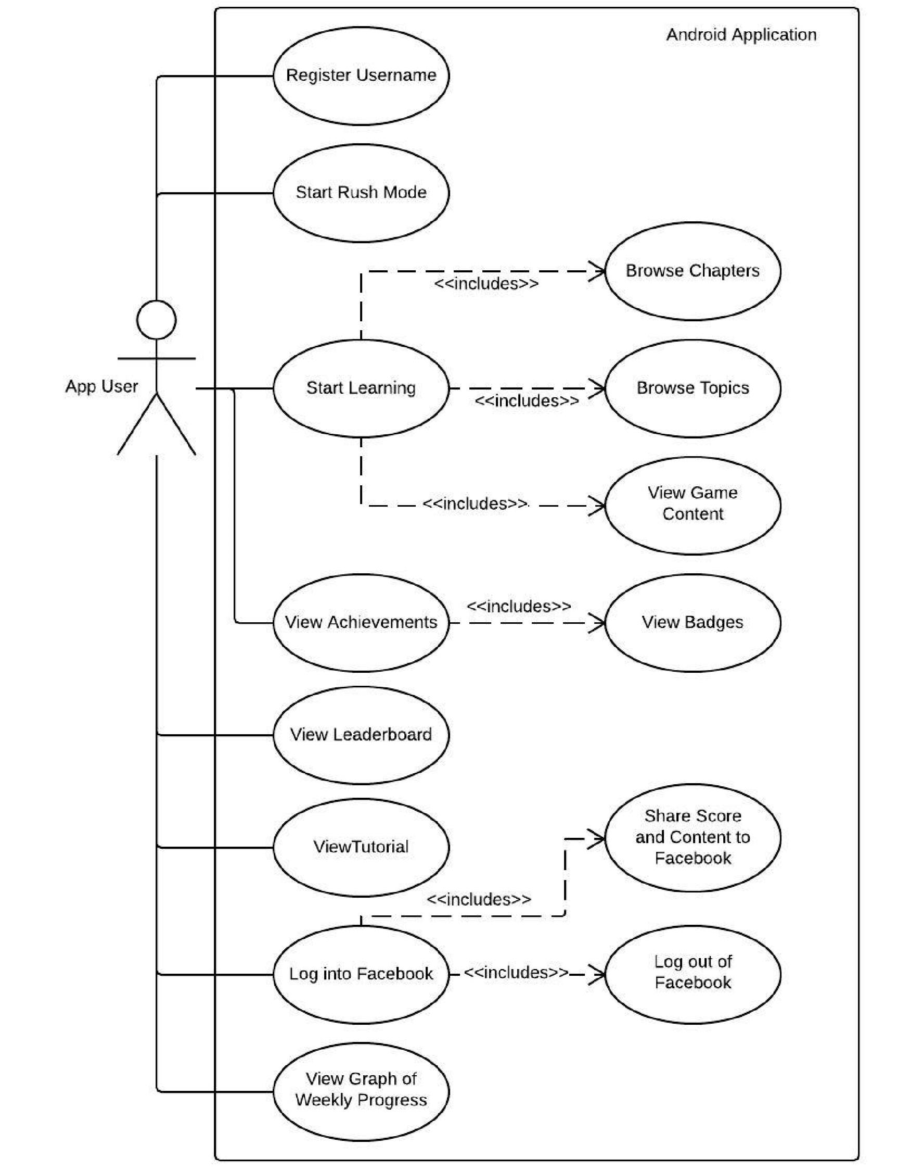

##### PHP Web Service

The PHP web service is an important aspect of this application as it will model the interaction between the Android application and MySQL Database. These use cases are a reference to what the web service expects from the database.

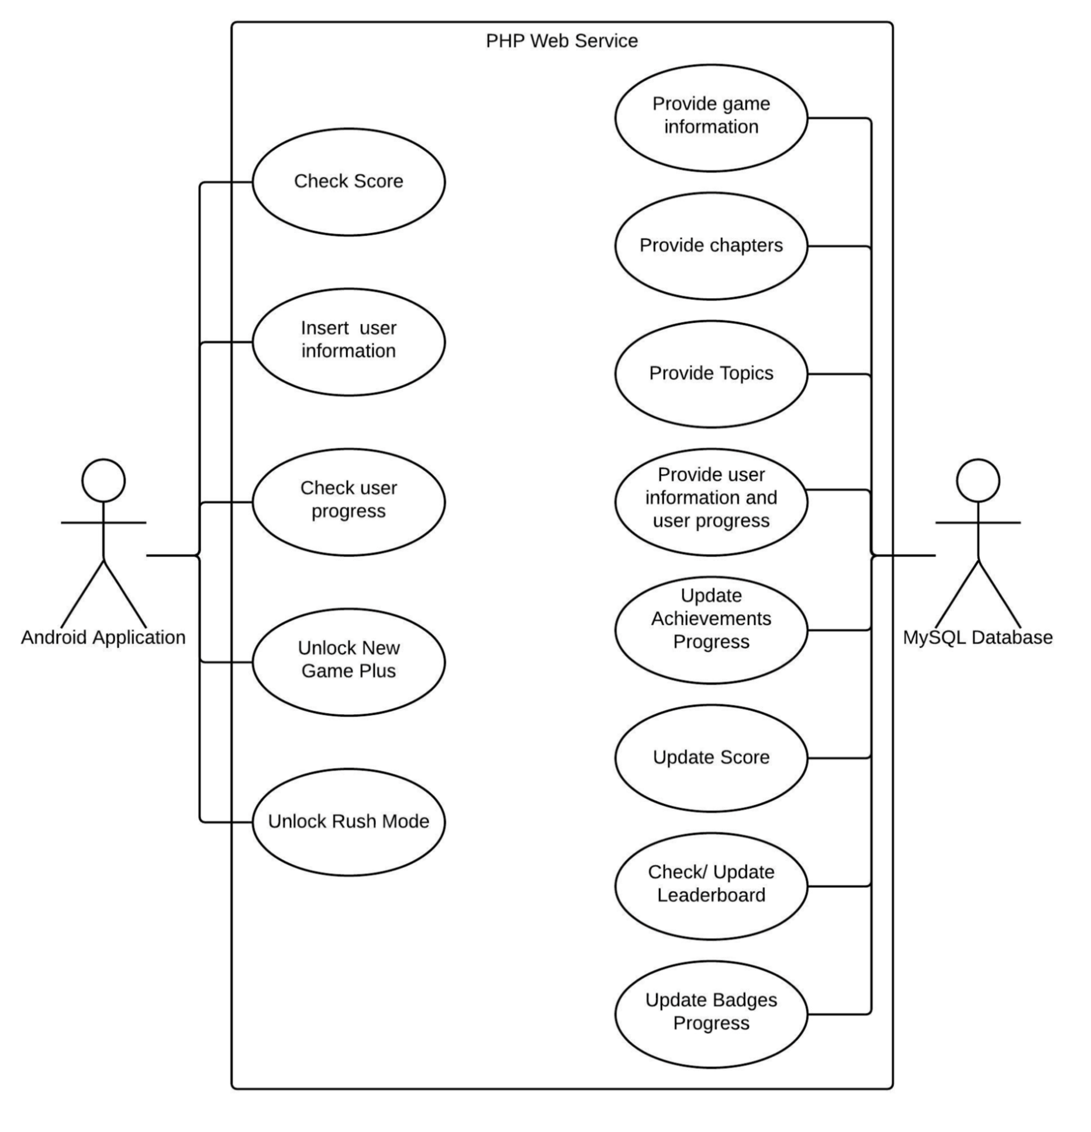

*Figure*

*3*

*Use case diag*

*ram For*

*PHP Web Service*

### **5.3.2 Sequence Diagram**

A sequence diagram, otherwise known as an interaction diagram, shows the interactions of objects across a time period and how processes operate with each other in what order. It typically depicts how the messages are exchanged between each object and the diagram is usually associated with use cases. Figure 4 shows the depiction of how start learning use case can be initiated and what messages are being exchanged. Figure 4 clearly shows the boundary classes and the entity classes and how they interact with each other across a time sequence. As an example, for the user to browse the chapters, a request will be sent to the database, the database will then return back the details of the chapters to the ‘Game_Type’ entity class, and then back to the user.

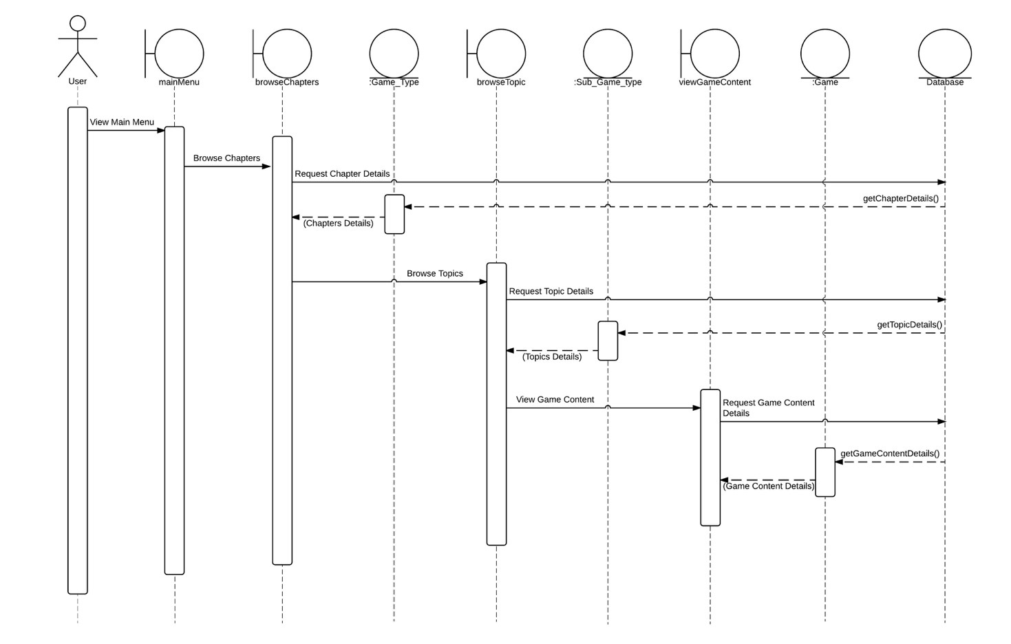

*Figure*

*4*

*Sequence Diagram for Start Learning Use Case*

## 5.4 ER Model Database Schema

The database model has to be completed and modelled correctly before implementing the application. A conceptual data model, logical data model and physical data model will be produced to visualize the business data in relation to the proposed product.

### **5.4.1 Conceptual Data Model**

The Conceptual Data Model is the highest level in the ER model which contains the least details, but lays out the foundation of what is to be included in the database. It identifies the highest level relationships between the different entities and at this stage, only the primary keys are identified and the attributes are yet to be acknowledged. In figure 5, the entities and the keys have been identified for the proposed product, and possible relationships have been drawn out to see the links between the table. Since this is an early stage of development, there may be a chance the model will have to be modified to either include or remove missing tables, primary keys and relationships. Any modification needed will have to be identified at an early stage and if any modifications are made, it will be logged.

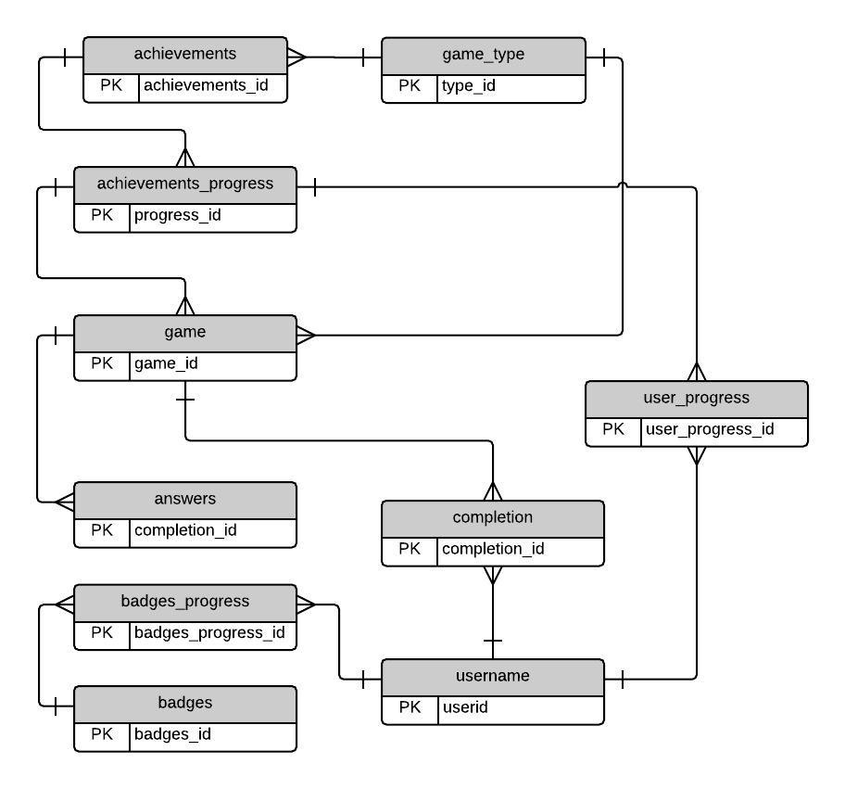

*Figure*

*5*

*Conceptual Dat*

*a Model*

### **5.4.2 Logical Data Model**

After identifying the entities, keys and the relationships in the Conceptual Data Model, the Logical Data Model expands on Conceptual and shows the detailed representation of the application’s business’s data. The model takes a further step to include the attributes and the relationships of the primary keys and the foreign keys between the entities. Figure 6 shows the possible attributes that will be needed for this project and the relationships of the foreign keys and primary keys. Figure 6 provides the foundation for designing the physical data model. Since this model is expanding from the Conceptual Data Model, any modifications made at this stage will have to be kept to a minimum to avoid the need of re-doing the whole ER model again. Any modifications made at this stage will also be logged.



*Figure*

*6*

*Logical Data Model*

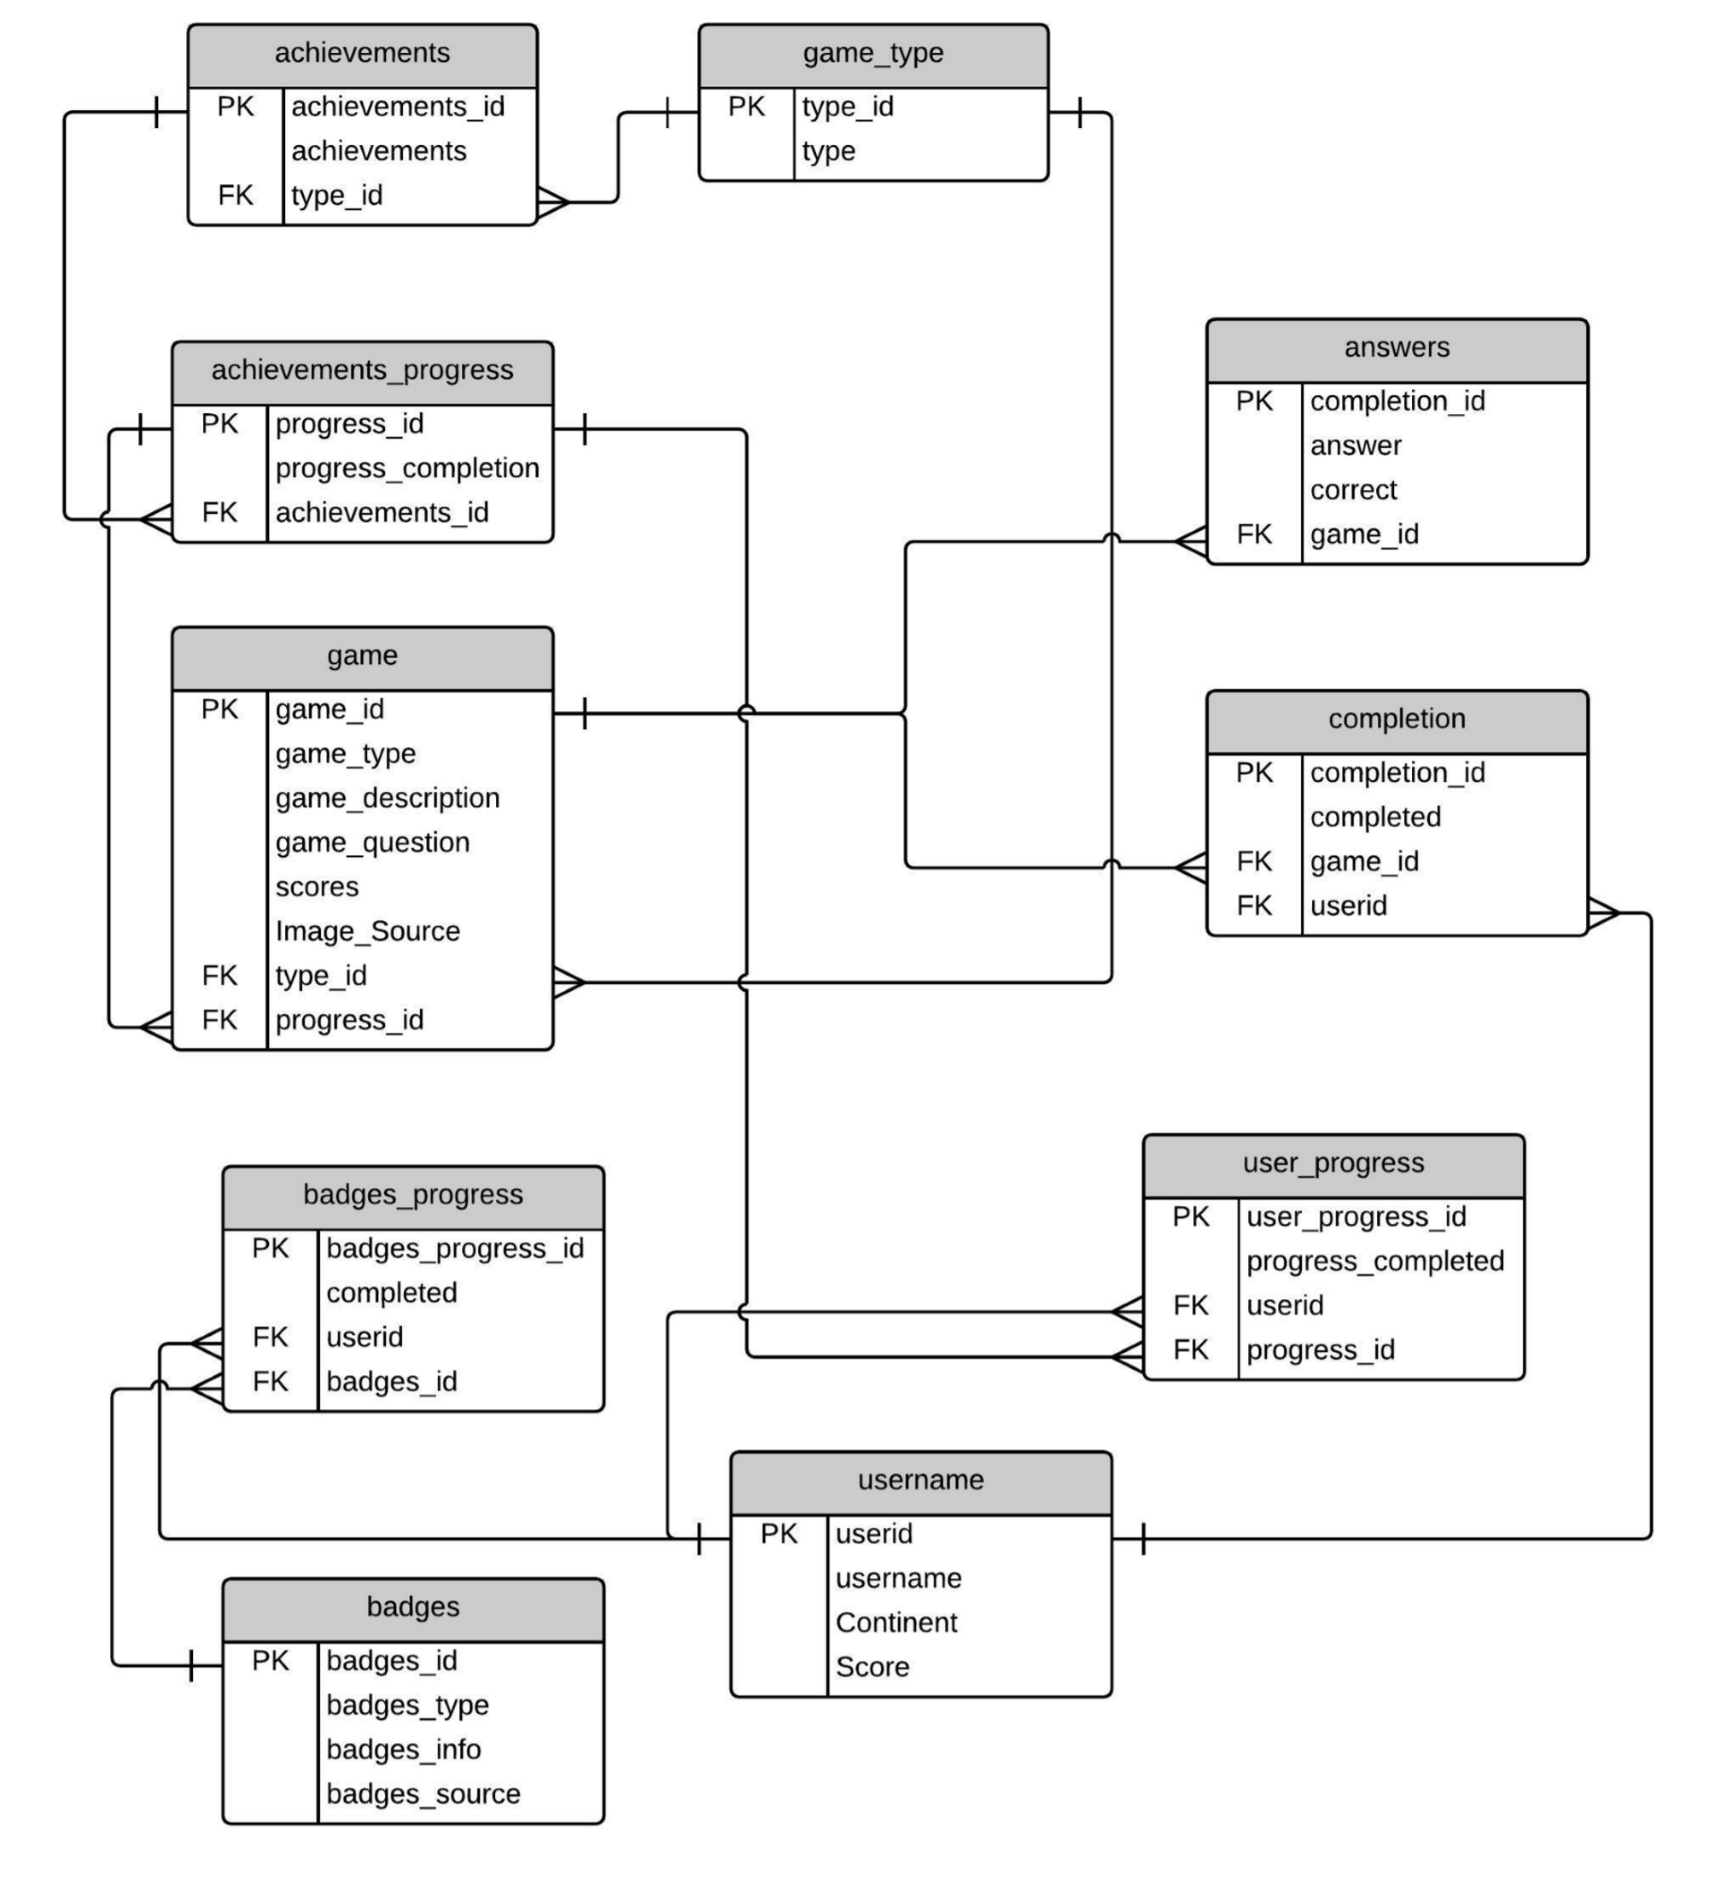

### **5.4.3 Physical Data Model**

The Physical Data Model is the final data model in the ER model. Expanding from the Logical Data Model, the Physical Data Model should contain enough details such as entities, keys, attributes and relationships to produce a database. The data types and the data length for each table’s attribute will have to be correctly identified so there is no error due to incompatible data types when actually creating the database. As this is the final data model, major modifications cannot be made at this stage otherwise it will be time consuming.

Any modifications made at this stage will also be logged.

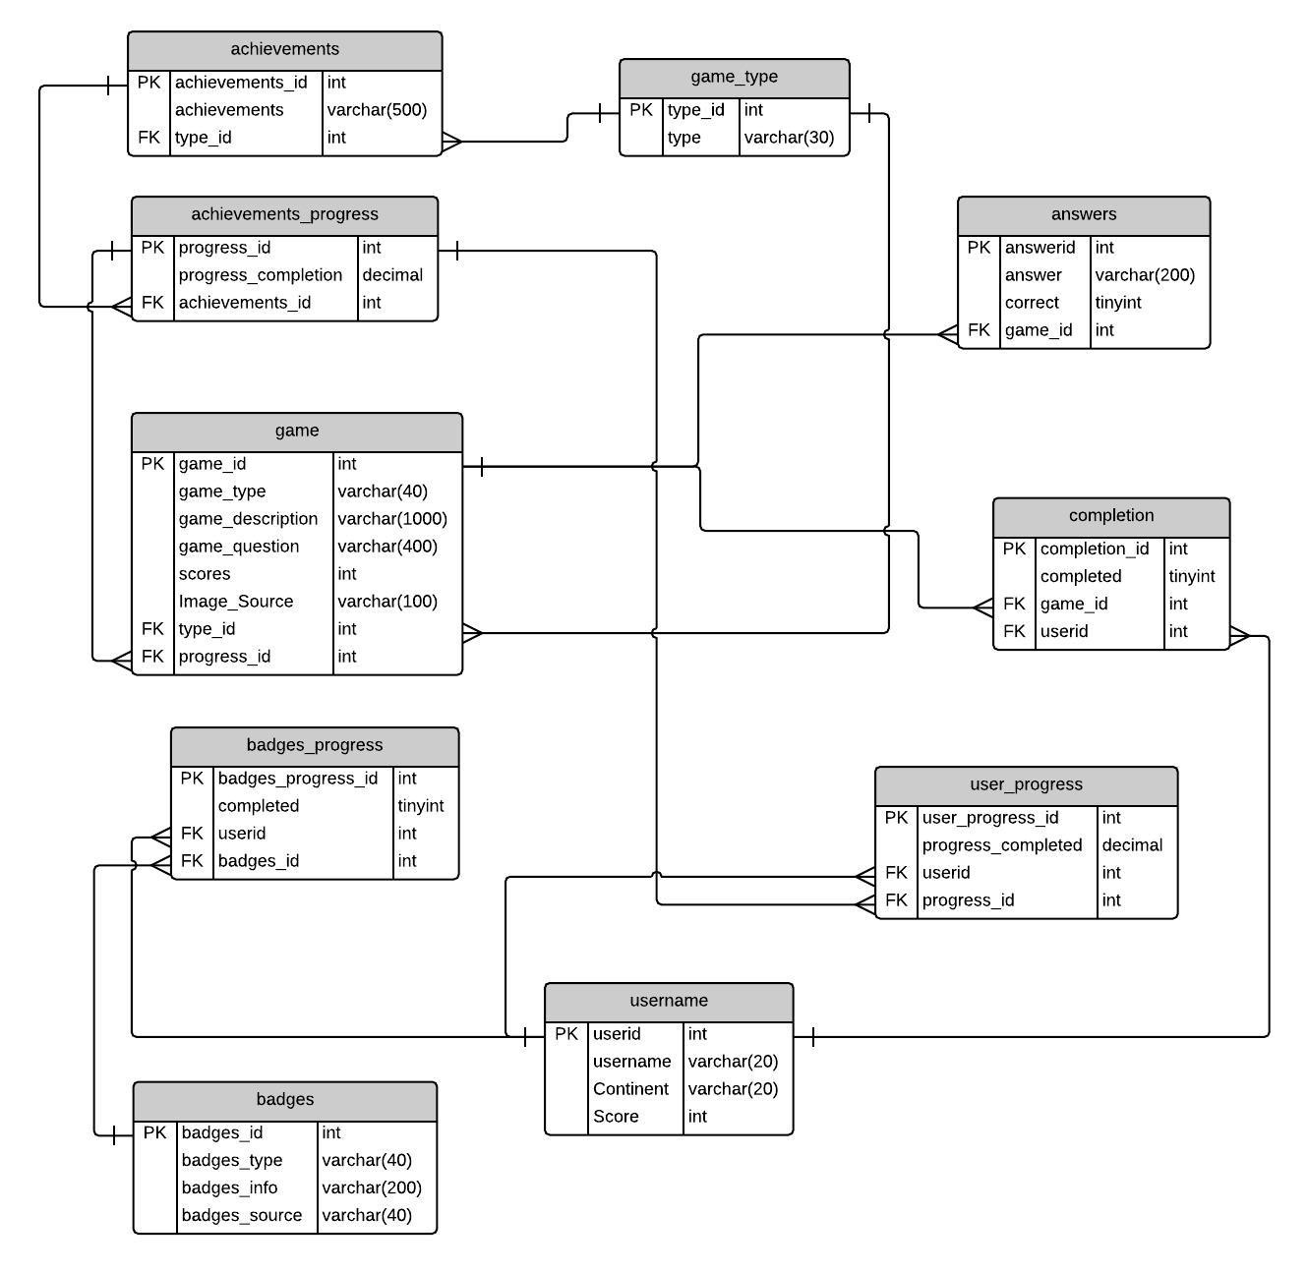

*Figure*

*7*

*Physical Data Model*

## 5.5 User Interface Design

Designing the prototype before any planning is crucial as this will define what the user interface would look like. Once the design is set, then can the implementation start in relation to the designs.

### **5.5.1 Wireframes**

Wireframes can be used as a blueprint to plan the structure, layout and the functionalities of the interface and help the designer to understand the relationship amongst the product’s contents, pages and elements in order to find out what works, and more importantly, what doesn’t. Designing without wireframes, the designer would merely be guessing the designs.

While designing the wireframe, a couple of Nielson’s Heuristics techniques have to be taken into consideration to ensure a high standard of the product is produced, and prevent from making mistakes where the reviewed products happen to do so.



Title



Username



Activity Page Name



C

urrent Progress



Start Learning

(

Button

)



**Head**



**Body**



*Figure*

*8*

*Wirefra*

*me One*

*-*

*Menu*

*Page*



Achievements/ Badges

)

Button

(



Rush Mode Leader board

)

Button

(



Tutorial

)

Button

(



Log In to FB

)

Button

(

The user interface seen in Figure 8 is divided into two sections, a head and a body. The head is seen as a master layout where it will be the identical across all the pages of the application. However, for the text in the head, this will change as this is handled in each activity. The body is seen as the content layout where it will be changed in every page. The Nielsen’s Heuristics technique, consistency and standards, should be adhered to where it states the layout should be consistent and professional throughout, ensuring the users can navigate around with ease.



Activity Page Name



Title



Chapters/Topics 1



Chapters/Topics 2



Chapters/Topics 3



Chapters/Topics 4



Chapters/Topics 5



Chapters/Topics 6



Chapters/Topics 7



Chapters/Topics 8



*Figure*

*9*

*Wireframe Two*

*-*

*Browsing Chapters/ Topics*

Figure 9 shows the wireframe of browsing through chapters or topics in a list view. List view can occupy the whole body screen and populate its data from an adapter which in therefore eliminates any unwanted white space and irrelevant information.



Content



List of possible answers



Score



Activity Page Name



Brain

Level



Image



*Figure*

*10*

*Wireframe Three*

*-*

*Game Page*

Figure 10 shows the wireframe for the actual game page. Once a user clicks on a topic, the game page should load up and show the content relating to that topic. The score should update automatically when a user selects an answer. Wrong answer should deduct the score and correct answer should increment the score. The brain level should depend on the score the user obtains, and should display what level they are at currently. The content should display the synopsis of the topic, the question and the score. The image and list of possible answers should be related to the question. The layout is consistent with the other previous wireframes and still adheres to the heuristics.



Activity Page Name



Position



Username



Score



List view of the leader

-

board



*Figure*

*11*

*Wireframe Four*

*–*

*Leader board Page*



List View of Specific User



Filter Spinner

Figure 11 shows the wireframe for the leader board page. The layout is still consistent with other and follows the head and body splitting. The list view of specific user should show the position, username and the score of that specific user that is using the application. The filter spinner should be able to filter the list by continents. The list view of the leader board should show all of the top users with the highest score with a set limit of 50.



Activity Page Nam

e



Achievements Tab



Badges Tab



List view of achievements/ badges



*Figure*

*12*

*Wireframe Five*

*–*

*Achievements/ Badges Page*



Text



Text

Figure 12 shows the wireframe for the achievements/ badges page. The tabs at the top should be a sliding tab so that the user can slide to one another and view the achievements and badges with ease. This user interface adheres to the heuristics, flexibility and efficiency of use, as it allows the user to view the achievements and badges in one screen.

## 5.6 Colour Scheme and Font Decisions

Choosing a correct colour scheme for the Android Application is crucial as this will determine how users will view the product. Using material pallete and having no more than 4 colours, where each should be known as primary (green), secondary (light green), accent (amber) and background (light grey-white) respectively, would provide a visually nice looking user interface. It is important to have a contrast between the four colours as this will ensure the content is readable.

Choosing a font style and size is important as this will be presented to the user, and they will be the one reading. Font style or size that is not readable will be a huge problem for the users. The font style that will be used in the Android application are the sans-serifs Prototype and Ubuntu fonts and the font size will vary according to context.

## 5.7 Pseudocode for Algorithms Used in Android Application

Creating pseudocodes for the algorithms that will be used in the Android application will be useful as it can be used as a guide when actually developing the product and reduce the time being wasted on debugging.

#### Question correctly answered should randomly increase lives

int lives = 5 int prob bool correctAnswer //Assuming the correct answer is retrieved from the database and stored in //correctAnswer

Random randomLives = new Random()

if (lives is greater than 1) { if (correct is equal to true) { set prob = randomLives.Next(1,101) //Sets a random difference between the two numbers if (prob is less than or equal to 15) {//Creates a 15% probability that a life will be increment //by 1 lives +=1 //Increment lives by 1

}

}

}

#### Randomly adding questions in a list for rush mode

Game game = new Game() //Assuming the class Game has been created which would hold the objects obtained from the database

List<Game> randGame = new List< Game >()

Random rand = new Random()

While loop (Count of randGame is less than the count of game) { int num = rand.Next (Count of game) bool containsQuestions = false Foreach loop (var x inside randGame){ if (game[num] is equal to x){ set containsQuestions=true

} } if (containsQuestions is not false){ then randGame.Add (game[num])

}

}

# 6 Implementation

This section will discuss the implementation process of the Android application, PHP web service and the database in accordance to the design.

## 6.1 Frameworks Required and Used in the Application

**Newtonsoft Json.NET Framework** - The JSON.Net library, by Newtonsoft (obtained from NuGet Packages), was used in this project to help with the serialization and deserialization of data interchanging, which is an easier way to store data. The library is a high performance JSON framework for .Net and it is typically faster than the .Net built-in JSON serialisers. The reason why JSON was chosen was due to the easy use and readable codes, and the library itself is open source.

An alternative to JSON.Net library would be to use XML library. However, XML requires open and close tags which could turn out to be a pain if one of the tags are missing. The XML parsing is slower compared to JSON.Net parsing and formatted JSON.Net is generally easier to read than formatted XML.

**Square Picasso** – The Square Picasso framework, by Picasso (obtained from NuGet Packages), was also used in this project. The framework allows the easy deployment of images on the application with a single line of code versus the many lines of code if no framework was used. The Picasso framework handles many of the common drawbacks of image loading on Android.



*Figure*

*13*

*A example of the Picasso Framework being used in the applic*

*ation*

Figure 11 shows an example of Picasso framework being used in the application in a single line of code. The ‘Load’ method loads the images from either a URL or from a local resource. The ‘Memory Policy’ and ‘Network Policy’ methods makes sure the images are not cached on the Android device to avoid using up the internal storage. The ‘Into’ method loads the image in the Image View control.

## 6.2 Android Application

The Android application was implemented in C# language using Xamarin Studio, following the design documentation. For full walkthrough of the working application, please refer to the screenshots available in Appendix B.

### **6.2.1 Prototype One**

Prototype one was focused on creating list views, list view adapters, communicating with PHP via web client and populating list views from the database. The initial start on prototype was to first learn how to create list views in the axml page (the designer page) and how to customize them. This lead onto referencing the list views in the activity page and creating list view adapters for the list views. Creating the adapter and communicating with PHP via web client was pretty straightforward.

Problem aroused when trying to populate the list views from the database as the data from the database was not correctly parsed as an JSON format. Without the correct JSON format, the list view would throw an exception error and crash the application. Learning from this problem, it was made sure the data from the database is correctly parsed as an JSON for a future reference to eliminate the risk of the application crashing.

### **6.2.2 Prototype Two**

Prototype two was focused on connecting to Facebook, logging into and logging out from Facebook, sharing a post on Facebook with the Facebook API and using Shared Preferences to store user settings. To use Facebook API, a Facebook developer account was needed which was made by a few simple steps provided by Facebook. Once created, Facebook required information about the application so it can be integrated. Since the application has an option to login to Facebook, the API required an extra information, the Android application’s key-hash, so it can authenticate the interactions between the application and Facebook. With all of the Facebook connection was done, logging into Facebook was a success. Once logged in, the API button changes to a logout button. Next on the list was to share content to Facebook. However, a problem was encountered when sharing a post to Facebook. The Facebook document guide shares a code in Java that allows to post a predefined message to Facebook. The coding was implemented into the application by converting the Java code into C#. When running the program and trying to actually post the predefined message, the message was blank. Upon researching answers on the internet, no possible solutions were found until a sample Facebook application specific to Xamarin Studio was looked upon. From there, it was realised the proposed product was missing a JavaCast casting syntax, which seemed pretty weird knowing no casting were ever needed. After adding the cast, the predefined message can now be then posted to Facebook. As for Shared Preferences, storing user settings was not a problem as it was a straight forward task.

### **6.2.3 Prototype Three**

Prototype three was focused on building the remaining functionalities that were not implemented in the previous prototypes. Since there were many functionalities to complete for this prototype, it took a very long time to do. The browsing of chapters and topics, the leader-board, the achievements/badges page, tutorial page were implemented first as the implementation was similar to prototype one. Problem was faced when trying to inflate the view of the achievements/badges page during runtime as the page was a sliding tab interface. The view would refuse to inflate and throw an error and crash the application. When debugging the application, the error was due to the inflate class inflating a parent view instead of a child view. Once the error has been corrected, the page inflated correctly during runtime.

The user progress, game page, and rush mode and the other remaining functionalities were implemented with no problems arising. The pseudocode algorithms in the design section were used in the game page and rush mode page, thus reducing the effort being put in.

### **6.2.4 Prototype Four**

The last and final prototype was focused on the actual user interface design in terms of colour scheme, handling errors, using validation rules and the layouts of the controls. Any errors the application throws up should be handled and shown to the user in a language they would understand. Validation rules should also be used wherever necessary to validate entries. The accessibility, usability and reliability requirements were taken seriously as this would determine how potential users would use this application. Failing to meet these requirements would either make or break the application. Prototype four was seen as the finished product as it attempted to meet all of the functional and non-functional requirements.

## 6.3 PHP Web Service

The web service was chosen to be created in PHP to ensure the maximum flexibility offered by PHP is utilized. The functionalities stated in the PHP Web Service Use Case diagram have been implemented as most of them were easy to do due to having knowledge and skills of PHP beforehand. However, a problem had risen when trying to array-push an array-filtered array back into a json format to get a specific username for the leader-board. Many attempts were made and each attempt kept on giving different results until there was a point where the array_values function in PHP to echo back out the value in the array was not being used. Getting stuck in those minor problems can be very time-consuming when there is a deadline approaching. Another problem had escalated when adding achievements progress and badges progress to each user. Initial idea was to add the progresses with no thought being given about the users. But doing so resulted in a problem where the progresses would cater for everyone using the application, meaning everyone would be updating the same achievements progress and badges progress. To solve this, another two entities had to be created in the database where it held the user’s progress for both achievements and badges respectively and the two current tables had to be modified. These two new entities would be then related back to the modified achievements and badges tables through foreign keys.

## 6.4 MySQL Database

The database was created in MySQL RDBMS Database using the physical data model as a guide. Creating and populating tables was a straightforward task except for one issue that had aroused. Using the MySQL query function, calculating the user’s progress of each achievement as a percentage turned out to be tricky as it had some maths involved and performing maths in MySQL needed extra research to understand the syntax. Doing some trial and error calculations on MySQL, the final calculation shown below turned out to be adequate:

Let x be the total number of topics in a chapter.

Let y be the user’s progress completed for that achievement.

Let z be the total progress needed to complete the achievement.

So the calculation would be:

y = (( ! * 100) + (#$$))

" %

Every time this math executes, the new user progress, y, will add onto the existing user progress, y instead of replacing the y. For example, the existing user progress has a value of 20.00, and the new user progress has also the value of 20.00. Instead of replacing the old value with the new value, they will be added together to have a value of 40.00.

As there many SQL statements used in the project, please refer to Appendix C to see a sample of major SQL statements used in PHP.

## 6.5 The option of New Game Plus

Once the user has completed all of the chapters and topics, achieved all of the achievements and has a 100% progress completion, the user has the chance to start a new game. But this time it will be New Game Plus, an option that resets specific user’s progresses and game data and keeps the user’s achievements/badges intact. However, the badges progress does not reset at all as there may be some badges that the user has not yet obtained in their first play through. The New Game Plus option allows the replay value and encourages the user to keep on playing to obtain the missing badges.

## 6.6 Sample of Android Codes

Samples of Android codes that are used in the project can be found in Appendix D.

# 7 Testing Documentation

This section will look at the approach in testing the Android application in order to produce significant test cases that covers all of the functionalities. The product would be then tested against the test cases and see whether it has passed or failed the test. If a certain test failed, then the action taken to be solved will be discussed and the test would be retaken.

## 7.1 Testing Strategy

Choosing a testing strategy is important as it will determine if the program has any defects and errors that may have been made at the development phase, or if the performance of the application is not satisfactory, or there may be bugs. Testing the product will make sure the product is free from these defects and bugs and will ensure the reliability and satisfaction of the product.

Black box testing is used to look at the core functionality of the system in which the internal structure of the product will not be known. This will allow to break down the system into small parts and test what parts work and what parts do not work.

White box testing involves looking at the code and trying to come up with tests that will test every logical statement that has been written and this will help to fix any errors that may be found. This type of testing requires internal knowledge of the system and adequate programming skills.

Black box testing will be chosen over white box testing to test the Android application. This is because it would allow the flexibility to code large segments of code even though the code access is not required. Below are the three main sections that have been tested and each sections will be summarised. The in-depth testing of the Android application is in Appendix E and the testing of the PHP Web Service/MySQL Database is in Appendix F.

## 7.2 Android Application

### **7.2.1 Prototype One**

Test plans were created for prototype one using black box testing criteria. The minimum functionality of the application was tested in this prototype as it had only this to offer. All of the test has failed except one. The connection to database failed due to a misdirection to another URI link but has been resolved now and is fully working.

### **7.2.2 Prototype Two**

The second prototype focused on connecting to Facebook, sharing content to Facebook and the usage of Shared Preferences. The test range involved testing the Facebook API integration and functionality. All of the tests that were carried out has passed and no problems were found.

### **7.2.3 Prototype Three**

The third prototype seemed to be the crucial prototype to be tested as it had so many functionalities. Carrying out the test cases in this prototype thoroughly would help in to detect any problems or bugs whatsoever. The tests ranged from the beginning of the lifecycle of the application to the end of the lifecycle and went through all of the screens. Surprisingly all of the test has passed except for one test where a graph was meant to show the weekly progress of a user. The graph was implemented but failed to show the results on the graph. The graph was unable to get the data from the database and plot the points. But due to time constraint, the graph requirement was left out at this stage and taken out from the application.

### **7.2.4 Prototype Four**

The last and final prototype test cases focused on the handling of errors and validation rules. The test shows the errors have been handled well and validation rules have been put in place. The test also managed to see if the application would perform if there was no internet connection. All of test cases passed except for one where the error is handled well but when the internet connection is lost during the game, the message is sometimes displayed to the user. Most of the time it would fail to show and just leave the screen as being blank thus making the user wait for a long time for a response action. The error was looked upon but no possible solution was found for it.

## 7.3 PHP Web Service/ MySQL Database

The PHP Web Service and MySQL database were tested together as they are practically doing the same thing. It tested the SQL queries and checked whether they are executing or not. These test cases were kept simple and straightforward. All of the test cases passed and no problems were found.

# 8 Evaluation

The approach to evaluating the implemented product was discussed briefly in the evaluation technique section of the report. The product will be first evaluated against the Nielsen’s Heuristics to see how the level of usability can be compared to the existing products. This chapter will also look at how successfully the product actually meets the statement of requirements and conducting a focus group to evaluate the overall product.

## 8.1 Nielsen’s Heuristic Evaluation of the Product

The product will be evaluated first with the Nielsen’s Heuristics. Below is evaluation of the product when it is compared with the three of the existing products.

#### ▪ Visibility of System Status

-Apart from the initial launch of the application where it shows the loading progress, the users are always informed and and provided with immediate feedback within a fast response time. Any feedback given to the users are provided by dialog boxes instead of toasts. The reason why toast was avoided is because it lasts for three seconds or so and the user might miss it and they would not know what was displayed. With the dialog box, the user can read the feedback without any time restriction and the user has to press ‘OK’ to continue.

#### ▪ Match Between System and the Real World

-The phrases and words used in this product has been kept to familiar terms to ensure the non-technical people have a mutual understanding of the application. There may be some terms that are related to programming since this product is about learning how to program, this will not hinder the interpretation of the users. The terms had to be used out of necessity.

#### ▪ Consistency and Standards

-The product followed the wireframe design and made sure the user interface is simple and consistent throughout the app. Keeping it simple made sure the user does not get lost when using the application.

#### • Error Prevention

-Whilst using the product with no internet connection, there were error messages being displayed to the user as a dialog box. The dialog would ask the user to check their internet connection and try again. Another error prevention is when the username field is left empty during registration, an error message would pop up. As for error messages popping up due to not being the user’s faults, there was none.

#### ▪ Flexibility and Efficiency of Use

-Since this application is simple and easy to use, the option for the users to adapt any frequent actions or preferences were not given. During the implementation phase, the product had taken into considerations for the experience and inexperienced users and provide them with an equally balanced product.

#### ▪ User Control and Freedom

-The product does not offer the option to backtrack or emergently exit. Since the application is on Android, a menu has not been implemented as the user can use the back button on the device to go back through screens. However, going back to dialogs box has been omitted due to being unnecessary.

#### ▪ Recognition Rather Than Recall

-Since the application has few screens from the main menu, it was a design choice not to include a menu bar where it can show options from every screen. But it may have been a bad choice to not include a menu bar as it might frustrate users to not having that complete freedom.

#### ▪ Aesthetic and Minimalist Design

-The product does not display any irrelevant and unnecessary information thus keeping the information simple yet effective to the user. The Nike + Fuel app seems to have used too much imagery so this product aimed to use less imagery but making it effective.

#### ▪ Help Users Recognize, Diagnose and Recover from Errors

-The error messages that displays to the user has been conveyed in plain English and offers advice to what the possible solutions are. If it’s the user’s fault, the advice will be directed to the user and what the possible solution are. If the errors are in the PHP web service or the database, the user will be notified as well.

#### ▪ Help and Documentation

-Help and documentation is implemented through out the application. The main bulk of the help is found from the main menu and tells the user how the application is meant to be used and what the purpose of this product is.

In summary, there were no major negative concerns of the application as the usability seems to be up to a satisfactory standard. The strongest quality of this product was keeping the product simple to use and not over complicated. The product offers help to any users that may need it and it is found on the main screen. As for preventing errors or displaying error messages in a language the user may know define the strongest aspect of this product as well. Any users will not want to encounter errors and not have a solution to it as this will be seen as a bad product. As for the colour scheme, they have been kept as simple as they can and have adhered to the colours mentioned in the design section. The negative aspect of this product may have been the omitted feature of a menu bar where it will allow to choose options from every screen.

## 8.2 Statement of Requirements Evaluation

The statement of requirements evaluation can be found in Appendix G.

As for the product to be deemed successful or not, it is imperative to see if the functionalities and nonfunctionalities have been met. As for functional requirements, all have been met except for one due to having difficulty implementing the graph and time constraints. As for non functional requirements, all may have been met, but some of them are partly met due to not taking into considerations the requirement is asking to do. As for the additional requirements, only one has been met out of the three as it had a MUST priority and had a direct relation to the aim of this project, which was to teach C#. The other two requirements may have not been implemented but it is not a deal breaker as they were only seen as some additional requirements. Taking these requirements into factor, the product can be regarded as being successful even though there were a few requirements missing. The aim of this project stated an implementation of an Android

Application that would make users learn how to use C# with gamification techniques implemented and this is what the intended product aimed to do.

## 8.3 Focus Group Evaluation of Product

The focus group is a generally used qualitative research technique which involves a small group ranging from 5 to 12 to undertake a meeting on a mutual interest which they offer feedback and opinions on a certain product with a moderator overlooking the process. Focus groups can be also used to evaluate products and can offer their opinions and thoughts on the prototype or final prototype and how it meets the aim of a project. For evaluation purposes, a focus group will be conducted to evaluate the developed product.

Conducting a focus group, the participants who volunteered were students from the University of Greenwich and their details have been kept anonymous. The feedback received from the participants were mostly positive with a few of them criticising some of the user interface features. The positive aspects were the simple and easy to use user interface, a good implementation of gamification techniques such as achievements, badges, leader board, scores and lives, a good use of breaking down chapters into topics where users will be able to understand each chapter in depth, a good attempt gamifying the game page where scores and brain level are used to determine the knowledge of the users, the notion of encouraging the users to play the game and attain 100% progress in order to unlock New Game Plus and Rush Mode and the use of Facebook to let the users share their highest score and encourage their friends to try the application. However, the negative aspects of this product that aroused from the focus group was the overusing of the colour green, not having more game modes such as memory based game, and making rush mode too hard to play as they thought the initial timer, being set to 45 seconds, was way too less. But most of the participants except one or two were being intrinsically motivated because of the extrinsic rewards implemented and felt like they were learning C# all over again from the beginning but with gamification. Even though there were few topics in each chapter, they thought it would have been great if there were more topics as they would have been able to learn more.

Taking the feedback into considerations, it is seen that the end results gathered from the focus group was mostly positive with some negatives. These negativity concerns can be tackled during the next big update of the application.

## 8.4 Future Updates

Future updates for the Android application has been looked upon and considered. Since most of the data arrives from MySQL database, it is possible to include additional chapters, topics, achievements and badges. This would mean the changes would have to be done at the server side without the client side ever knowing. The client side would just have to receive a simple update to add in the missing progresses, in order to cater for these changes. Another consideration was to add more game modes to the application where the users would be able to choose how to tackle a topic in a particular game mode. For example, they can tackle a topic where the answers are only displayed for a few seconds and disappear thereafter and they are asked to type in the correct answer. Anything along those lines where introducing new game modes would expand the lifetime of the application. The last consideration is to expand the product to include iOS and Windows platform. From the technical review, it is seen that using PCL or Shared Asset can be an easy solution to cross-platform development.

# 9 Conclusion

This chapter will review the project process, if the product could have been improved if there was more time and if it was to be done again, what changes could be made.

## 9.1 Review of Project Process

As with all projects, it is important to plan out every stage of the development phase to ensure all criteria is met. A project proposal was conducted and can be found in Appendix H. The proposal covered the aim, objectives and the deadlines. The proposal helped to manage the deadlines of this project and other projects as they had to balance out. Throughout the lifecycle of the project, a conceptual and interim deliverable had to be uploaded. But due to my project proposal being accepted late, the process of the project was slightly hindered. Nevertheless, even before being accepted, progress was being made in the literature and technical reviews and minor changes have been made to cater for the accepted proposal. Due to unforeseen circumstances, the deadlines mentioned in the proposal have not been met thus being the timings for the tasks were not effectively managed. However, the project was back on track after proposal being accepted.

Conducting the literature review and the existing product review might have been the trickiest part of this project. Researching and reading articles, journals and books for the literature review was difficult due to making sure the correct literature was being looked into and it took a lot of the time up. As for the existing product review it was difficult to choose what products to review and what products to not review as some of them were really bad in terms of their overall product content. The rest of the project process was fairly straightforward due to having the knowledge and skills gained from previous projects. The process has not been a smooth process as problems were encountered with both the Android application and PHP.

## 9.2 Critical Evaluation of Product

An in-depth evaluation of the product can be found in the evaluation section of the report. The product was completed on time and before the final deadline date, and it was seen as a success as it met the requirements. There may be two or three requirements that have not been met, but their MoSCoW priority was very low so it is not a problem.

If any changes were to be made to the product or if it was to be done again, then the missing requirements would have been implemented first and changes would have been made following the focus group feedback and the heuristics feedback. In addition, the implementation of the graph would have been looked into earlier at the development phase to ensure it gets implemented.

Overall the product has been developed to a high standard and to the best of the developer’s ability. A slight change, tweaks and a few additions of features of the application would have been a great.

## 9.3 Critical Evaluation of Personal Performance

Upon completing this project, I have expanded on my knowledge and skills and acquired new knowledge that I am proud of and will take away with me. Using Xamarin Studio has further increased my knowledge of C# as well as using PHP and SQL. This project has enabled me to understand and given me the ability of project management skills and undertake any project management role if given the chance. The greatest thing that I have learnt is how to develop applications for Android, and this has made me consider a possible career along the development of Android apps or even general mobile development.

Overall, I am happy with the work I have produced and the performance and efforts that I have put in.

However, more work is needed in managing time and deadlines, and keeping track of the project plan.

# 10 References

Baddeley, A., Thomson, N. and Buchanon, M. (1975). "*Word length and the structure of short-term memory*". Journal of Verbal Learning and Verbal Behaviour. Vol. 14. pp. 575-589.

Deterding, S., Dixon, D., Khaled, R. and Nacke, L. (2011). “*Gamification: Toward a Definition*". ACM Press, Vancouver. Canada. pp. 1-3.

Hamari, J., Jonna, K. and Harri, S. (2014*).* "*Does Gamification Work? -- A Literature Review Of Empirical Studies On Gamification*. 47th Hawaii International Conference on System Sciences: pp. 3025-3026.

Hussain, T. (2015). "*User Interface Design (COMP 1650)*". Greenwich. pp.10-12

Jakubowski, M. (2014). "Gamification in business and education project of gamified course for university students." *Developments in Business Simulation and Experiential Learning,* Volume 41:Pg 339.

Jayasinghe, U. and Dharmaratne, A. (2013). "*Game based learning vs. gamification from the higher education students' perspective*". Proceedings of 2013 IEEE International Conference on Teaching, Assessment and Learning for Engineering (TALE*)*.

Laskowski, M. (2013). “*A short overview of pros and cons of gamification*”. Actual Problems of Economics.

Vol. 145. No. 7. pp. 373-377

Laskowski, M. (2015). "*Implementing Gamification Techniques Into University Study Path - A Case Study*." 2015 IEEE Global Engineering Education Conference (EDUCON*)*: pp. 582-583.

Peeters, M., Megens, C., Hoven, E., Hummels, C. and Brombacher, A. (2013). "*Social Stairs: Taking The Piano Staircase Towards Long-Term Behavioral Change*". Persuasive Technology: pp. 174-179.

Pritchard, A. (2014). *Ways Of Learning: Learning Theories and Learning Styles in Classroom.* 3rd edn.

Oxfordshire: Routledge.

Ryan, R. and Deci, E. (2000). "*Intrinsic and Extrinsic Motivations: Classic Definitions and New Directions*". Contemporary Educational Psychology. Vol. 25. pp.54-67.

Zichermann, G. and Cunningham, C. (2011) *Gamification By Design Implementing Game Mechanics in Web and Mobile Apps.* Sebastoplol: O’Reilly Media. pp.1-5

ColeyConsulting, 2015. *MoSCoW Prioritisation*. [Online] Available at: http://www.coleyconsulting.co.uk/moscow.htm [Accessed: 21/02/2016]

Gartner, 2012. *Gartner Says by 2014, 80 Percent of Current Gamified Applications Will Fail to Meet Business Objectives Primarily Due to Poor Design.* [Online] Available at: http://www.gartner.com/newsroom/id/2251015 [Accessed: 05/01/2016]

Nielsen Norman Group. Jakob Nielsen. (1995). *10 Usability Heuristics for User Interface Design.* [Online]

Available at: https://www.nngroup.com/articles/ten-usability-heuristics/ [Accessed: 24/02/2016]

Nexino Labs Pvt Ltd, 2016. *Programming Hub.* [Online] Available at: https://play.google.com/store/apps/details?id=com.freeit.java&hl=en_GB [Accessed: 19/03/2016]

Nice Inc, 2015. *Nike + Fuel*. [Online] Available at: https://play.google.com/store/apps/details?id=com.nike.fb&hl=en_GB [Accessed: 19/03/2016]

SoloLearn, 2016. *Learn Programming with Swift (From 'Google Play'* Store*)*. [Online] Available at:

https://play.google.com/store/apps/details?id=com.sololearn.swift [Accessed: 19/03/2016]

# 11 Appendices

## 11.1 Appendix A - Existing Product Reviews Evaluation

#### **Learn Programming with Swift**

##### ▪ Visibility of System Status

-The user is able to see and be informed about what is happening on the interface all the time. There is immediate feedback provided at a fast rate. An example of this is when the user clicks on leader board and the system notifies the user it is being retrieved.

##### ▪ Match Between System and the Real World

-The phrases and words used in this product is understandable and no problems would arise from it. Since this app is a programing app, some words are in relation to the swift language due to its necessity.

##### ▪ Consistency and Standards

-The layout and structure seems professional and consistent throughout, there are no abnormalities. The user will not be able to get confused.

##### • Error Prevention

-There are error messages in place for this product. An example is when trying to sign in to their server and if the field is left empty, a dialog pops up notifying the user that the field has been left empty.

▪ Flexibility and Efficiency of Use

-This product is very easy to use and navigate around and should be suitable for the inexperienced users.

##### ▪ User Control and Freedom

-The product offers the option to backtrack to wherever it needs to go. There is an emergency exit button in place that allows the user to click on that and backtrack all the way back to the main menu.

##### ▪ Recognition Rather Than Recall

-All of the instructions, actions and options are visible to the user on every screen. There is a navigation tab on the left hand side of the screen that allows the user to have more options to choose from. The home screen is easy recognisable as the layout is simple.

##### ▪ Aesthetic and Minimalist Design

-The product does not display any irrelevant information thus keeping the information simple yet effective to the user.

##### ▪ Help Users Recognize, Diagnose and Recover from Errors

-The error messages are displayed to the user in a way that they will be able to understand. It is displayed in plain English.

##### ▪ Help and Documentation

-There are no help or documentation found for this product. It does not offer the concrete steps that should be carried out.

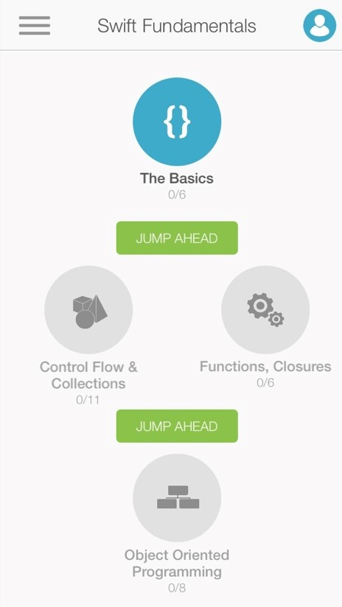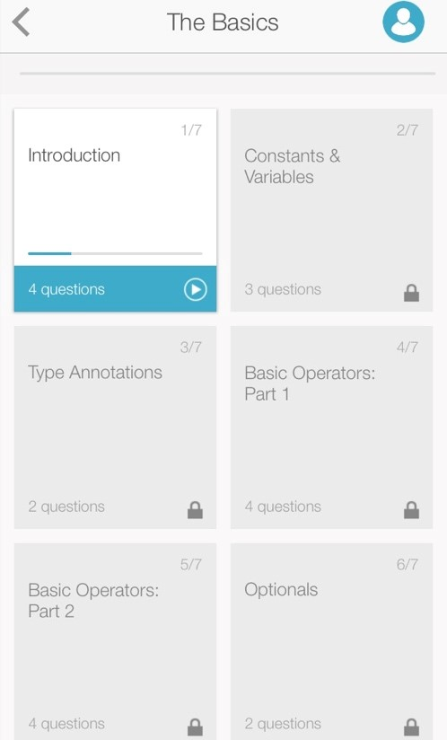

This is the screen where the user

chooses a selection. The selection

is laid out in a list view and they

are all locked except the first one.

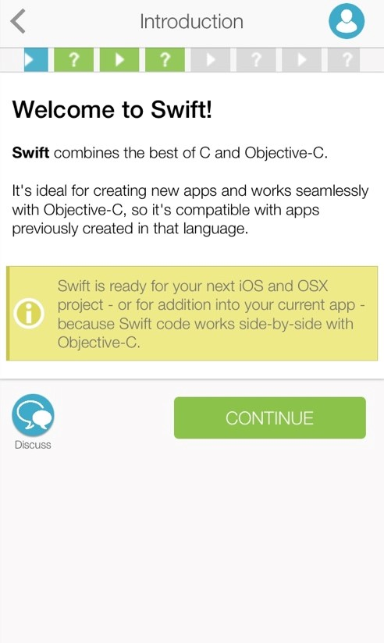

This is the screen where the user is

introduced to the language. The use

of colours and layout makes it lo

ok

well pleasing to the eye.



This is the home page of the

product. The menu is well laid

out. It has a menu bar toggle on

the left.

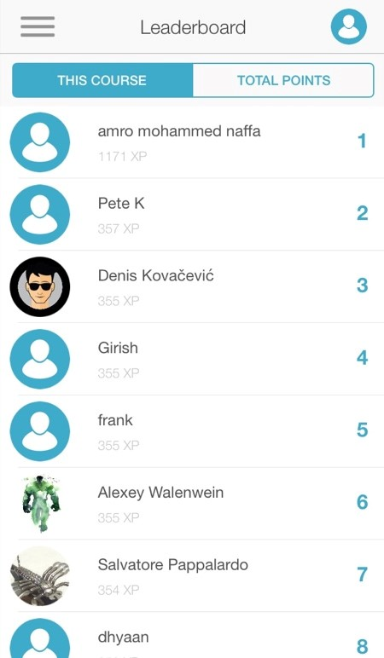

This is the

leader board screen

where it has been gamified. It

displays the positions of the users

of this product. The u

se of avatar

helps the user to identify their

competition.

#### **Programming Hub**

##### ▪ Visibility of System Status

-The user is able to see and be informed about what is happening on the interface all the time as it is simple. There is immediate feedback provided at a fast rate. The contents seem to be all implemented using a list view.

##### ▪ Match Between System and the Real World

-The phrases and words used in this product is understandable and no problems would arise from it. Since this app is a programming app, some words are related to the many languages in the app due to its necessity.

##### ▪ Consistency and Standards

-The layout and structure seems professional and consistent throughout. The user will not be able to get confused.

##### • Error Prevention

-There are no error messages being displayed across the product so it will be hard to test this heuristic. It is assumed the application is free from error.

##### ▪ Flexibility and Efficiency of Use

-This product is very easy to use and navigate around and should be suitable for the inexperienced users. However, when viewing the topic, there is no information telling the user what it is all about. It is just codes thrown at the user.

##### ▪ User Control and Freedom

-The product offers the option to backtrack to wherever it needs to go. Allows the total freedom of the user to do whatever they want.

▪ Recognition Rather Than Recall

-All of the instructions, actions and options are visible to the user on every screen.

##### ▪ Aesthetic and Minimalist Design

-The product does not display any irrelevant information thus keeping the information simple yet effective to the user.

▪ Help Users Recognize, Diagnose and Recover from Errors

-There should be errors first in this product for the error message to be displayed.

##### ▪ Help and Documentation

-There are no help or documentation found for this product. Does not offer concrete steps to be carried out.

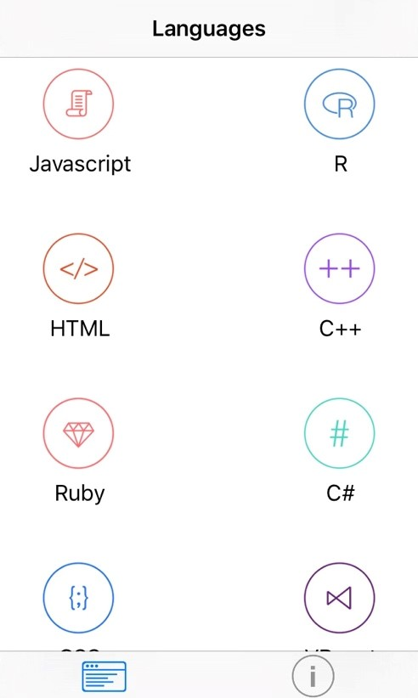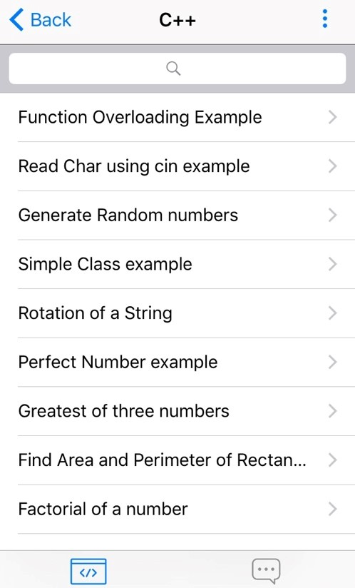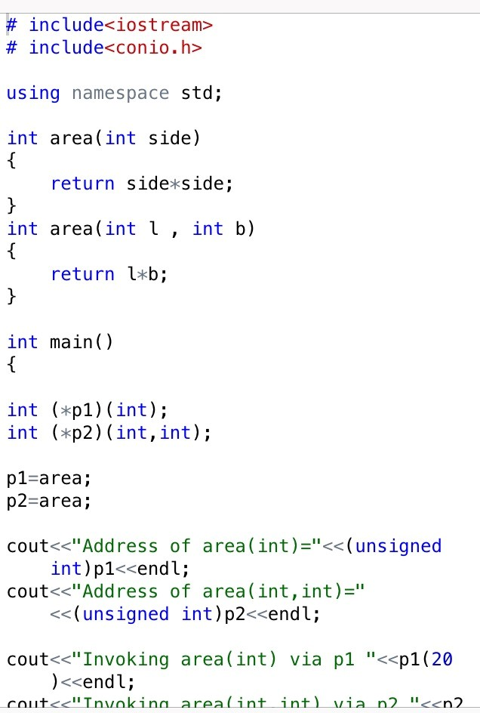

This is the

home

screen

when it

launches. The

user

can choose

a

variety of language

. The selection

is laid out in a list

view. The

layout is simple and easy to use.



This is the screen where the user

chooses a selection. The selection

is

laid out in a list view.



This is the screen where

it could be

controversial

.

There are no

instructions as to what to do. Only

codes appear as images

#### **Nike + Fuel**

##### ▪ Visibility of System Status

-The user is able to see and be informed about what is happening on the interface all the time. There is a slight delay with each pages being loaded up but nevertheless it is still fast.

##### ▪ Match Between System and the Real World

-The phrases and words used in this product is understandable and no problems would arise from it. The user would be able to understand it as it is familiar to them.

##### ▪ Consistency and Standards

-The layout and structure seems consistent throughout with the different use of colours and blend, and it cannot be faulted.

##### • Error Prevention

-The product seemed to have error prevention in place. An example is when trying to sign in to their server and if the field is left empty, a dialog pops up notifying the user.

##### ▪ Flexibility and Efficiency of Use

-This product is very easy to use and navigate around and should be suitable for the inexperienced users.

However, some the controls seem to be vague as it provides too less information.

##### ▪ User Control and Freedom

-The product offers the option to backtrack to wherever it needs to go. There is an emergency exit button in place that allows the user to click on that and backtrack all the way back to the main menu.

##### ▪ Recognition Rather Than Recall

-All of the instructions, actions and options are visible to the user on every screen. There is a navigation tab on the left hand side of the screen that allows the user to have more options to choose from.

##### ▪ Aesthetic and Minimalist Design

-The product does not display any irrelevant information thus keeping the information simple yet effective to the user. However, even the relevant information seems to be cramped up on the screen and the user may feel distracted or bothered.

##### ▪ Help Users Recognize, Diagnose and Recover from Errors

-The error messages are displayed to the user in a way that they will be able to understand. It is displayed in plain English.

##### ▪ Help and Documentation

-Help and documentation is buried in this product as the user has to search for them. Even though the help is not that useful and does not relate directly to the product, it still offers other advice about the Nike product. found for this product.

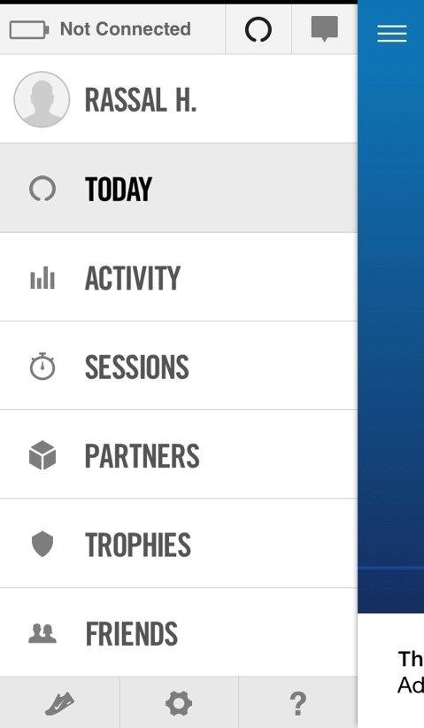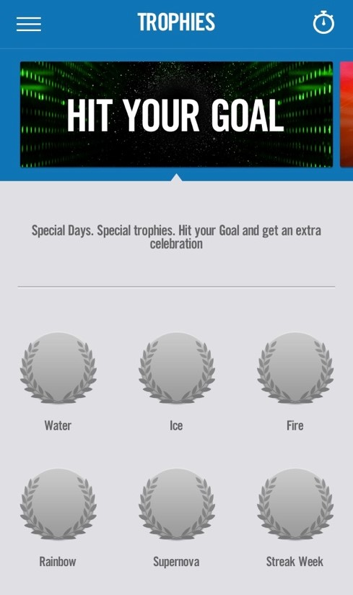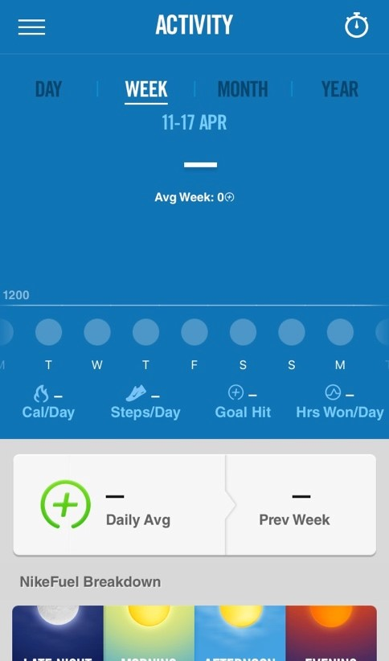

This is the

navigation tab that is

accessible from anywhere.



This is the

trophy screen where

the application has been gamified

to attract more users

.



This is the screen where it shows

the progress of the user in a

graph.

## 11.2 Appendix B – Screenshots of working program

#### Register Screen

Upon launching the application for the first time, the app will ask for the user to register their name and their place of location (continent).

Once the button is clicked, the details will be saved in the database and in shared preferences.

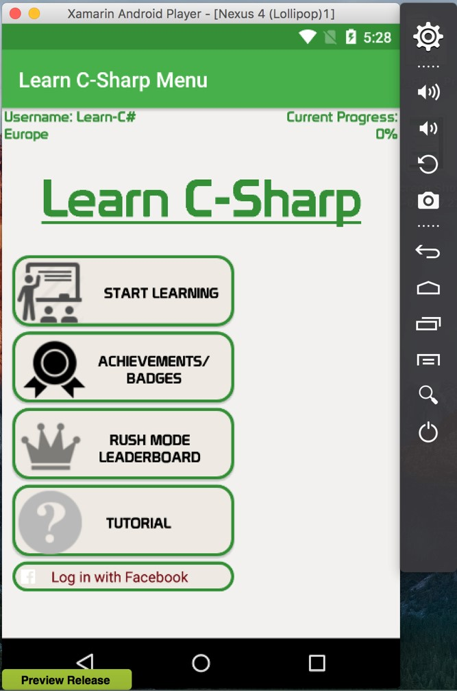

#### Menu Screen

Once registered, the user will be redirected to the menu page as shown on the screenshot. The page will show the user’s details and their current progress. From this screen, the user can select where they want to go next.

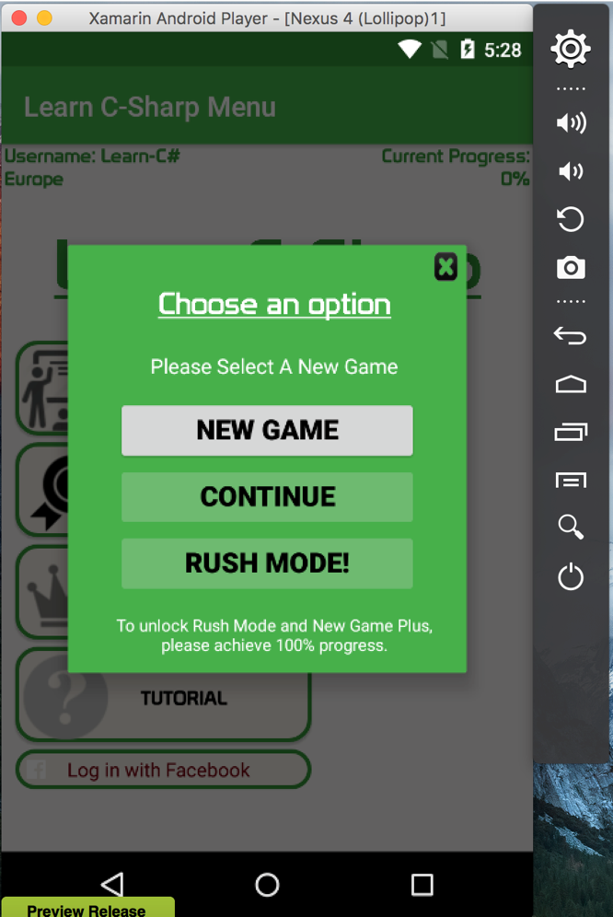

#### Sub Menu Dialog Screen

Once the user selects ‘Start Learning’ from the previous screen, a dialog screen will pop up asking to choose an option as shown in the screenshot. At this moment, only ‘New Game’ can be started and Rush Mode and New Game Plus will be locked until 100% progress is achieved. This adds replay value to the application.

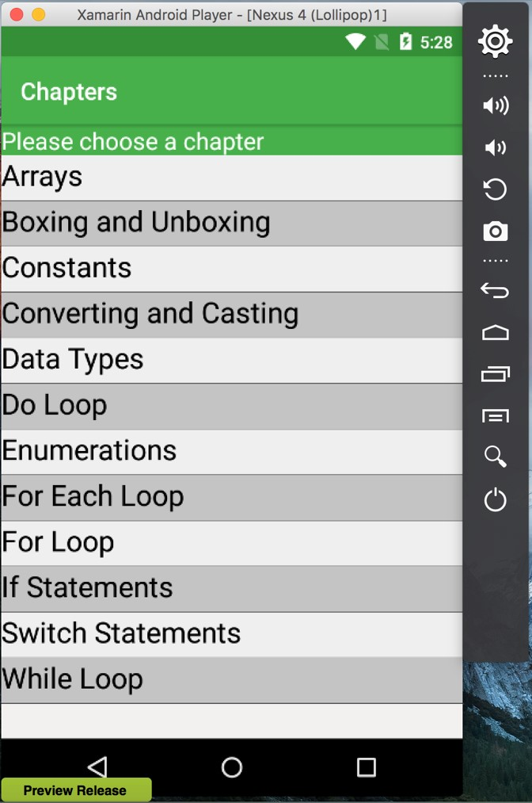

#### Choosing a Chapter Screen

Once a New Game is selected, the user is able to select a chapter. To avoid any game limitations, all of the chapters are unlocked on the go. Each chapter contains many topics.

More chapters can be added later via an update. This would ensure the lifetime of the application.

#### Choosing a Topic Screen

Once a user selects a chapter, they are able to select topics in relation to that chapter. In this case, the screenshot shows the topics of the chapter ‘Array’.

The ‘C# Brain Size’ is the game’s own unique score attribute. The score will be saved in a shared preference.

Each topic is accompanied by a completed attribute, so this will determine if a particular topic has been completed or not.

At the bottom of the screen, the user is notified how much they have completed for the achievement for that particular chapter and what badges they have obtained.

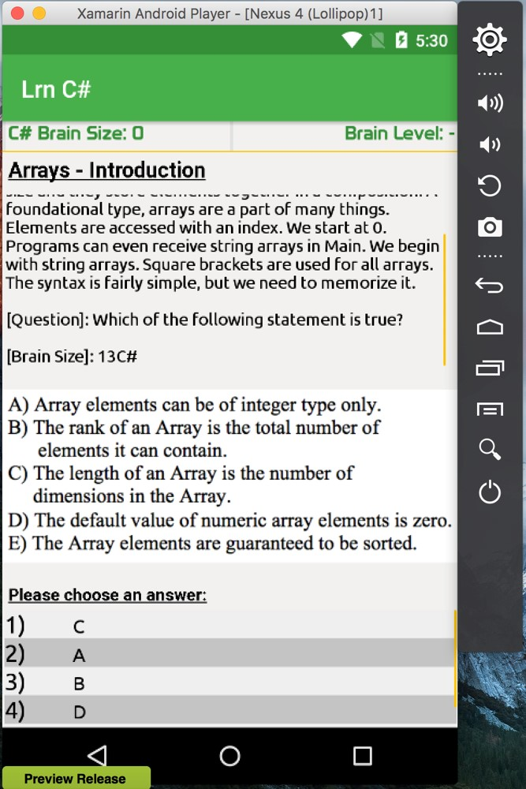

#### Game Page Screen

Once a user selects a topic, they are redirected to the game screen. The user is given a brief synopsis of the topic, a question to the answer in relation to the image, and the brain size worth for the question. The list of possible answers is given below in a list view. To further help the user see the contents, scroll view has been enabled in both the list view and text view.

#### Wrong or Correct Answer Screen

Once the user selects an answer, the user is notified if the answer is correctly answered or wrongly answered. If correctly answered, the user is awarded with brain size score and if wrong answered, the brain size id deducted by a random number between 5 and

15.

#### Choose a Topic Screen – Completed Topic

Once the user chooses a correct answer, the user is redirected back to the topic screen. The topic they have completed is automatically updated with a green tick, and the achievement’s progress is calculated automatically as well.

The badges are not yet obtained due to not hitting a specific brain size score.

#### Choosing a Topic Screen – Completed Achievement

Once the topics are all completed in a given chapter, the user is notified of achieving this achievement. The badges also have been obtained after hitting a specific brain size score.

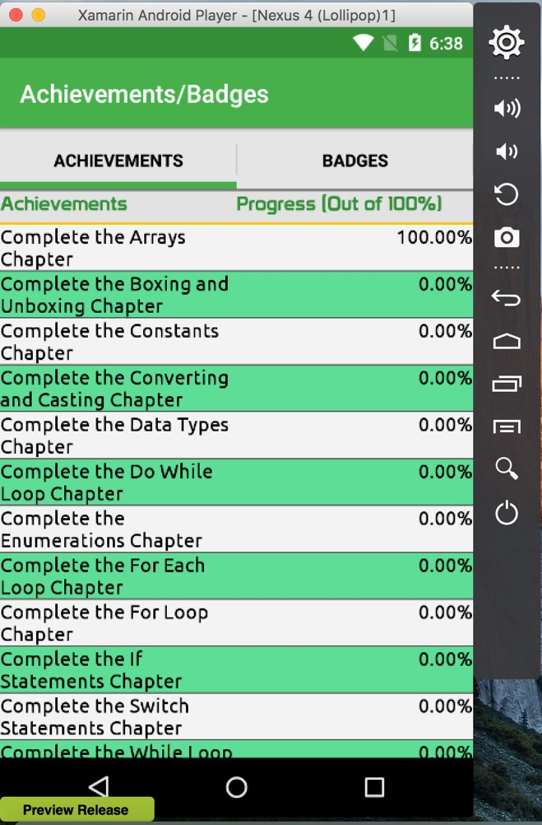

#### Achievements Screen

Selecting the achievements page from the main menu, it is seen that the ‘Arrays’ chapter has a completion of 100%, whilst the others chapters still have 0%.

#### Badges Screen

The badges screen can only be accessed by going into the achievements screen. The screen has been implemented using sliding tabs interface.

The badges show what the user has unlocked and what the user needs to unlock.

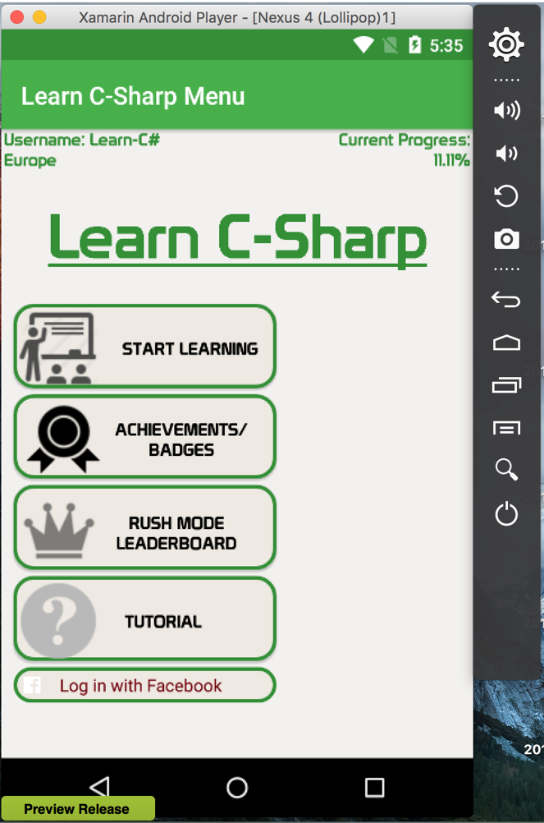

#### Menu Screen – Updated user progress

The user overall progress has been updated after completing the topics.

#### Rush Mode Screen

The rush mode is only unlocked when the user has a 100% progress.

During the rush mode, the user is given all of the questions from the normal mode and expected to answer them within a time limit and a set amount of lives.

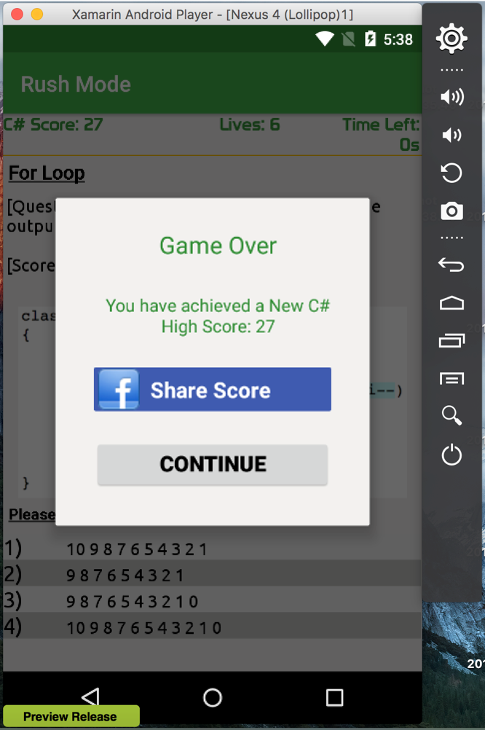

#### Share Dialog Screen

Once the user finishes all of the questions, or the time is up or the lives hits 0, then the game is over. The user has the chance to post their highest score to their Facebook.

#### Facebook API – Share Screen

The user can post a predefined post which contains their highest score and and a text that challenges their friends, and write their own message. The link is also hyperlinked to a rush mode leader-board that is available on the website.

#### Shared Message on Facebook



The user profile picture and name has been left out due to privacy purposes.

The content from the previous screenshot has been shared on Facebook.

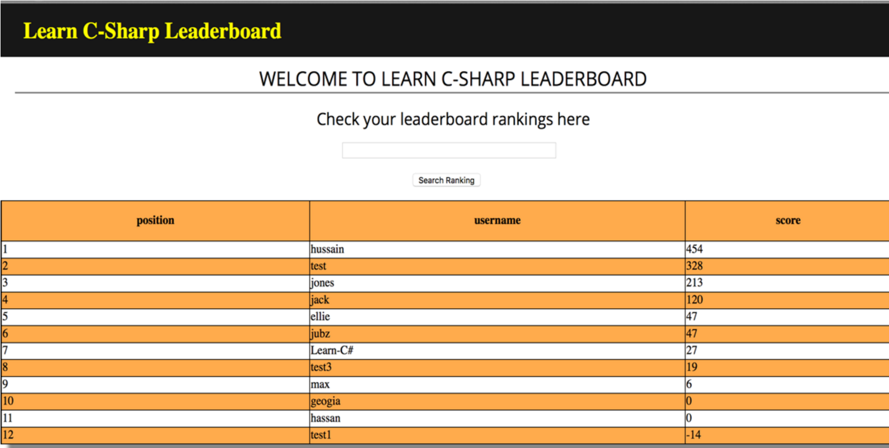The link on the Facebook post redirects to this page, where the rush mode leaderboard is shown. Users can search for their username to reveal their position only.

#### Rush Mode Leader-board

The user can see the rush mode leader-board from the main menu and see what position they are in. this encourages competition between players. The user can also filter the board by continent.

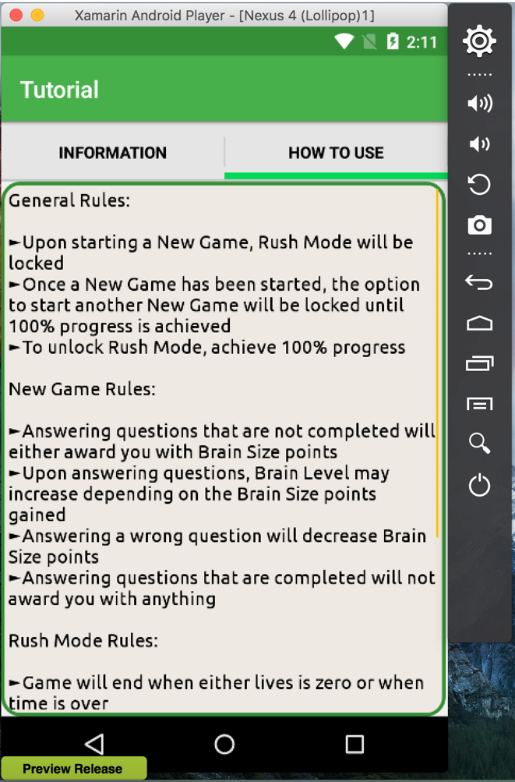

#### Tutorial Screen

The tutorial screen can be seen from the main menu. The screen provides information on how the application should be used and vice versa.

## 11.3 Appendix C – Sample of SQL Statements used in PHP

‘

Add

ing

User

’

‘Get

ting

Specific Leader

-

board’

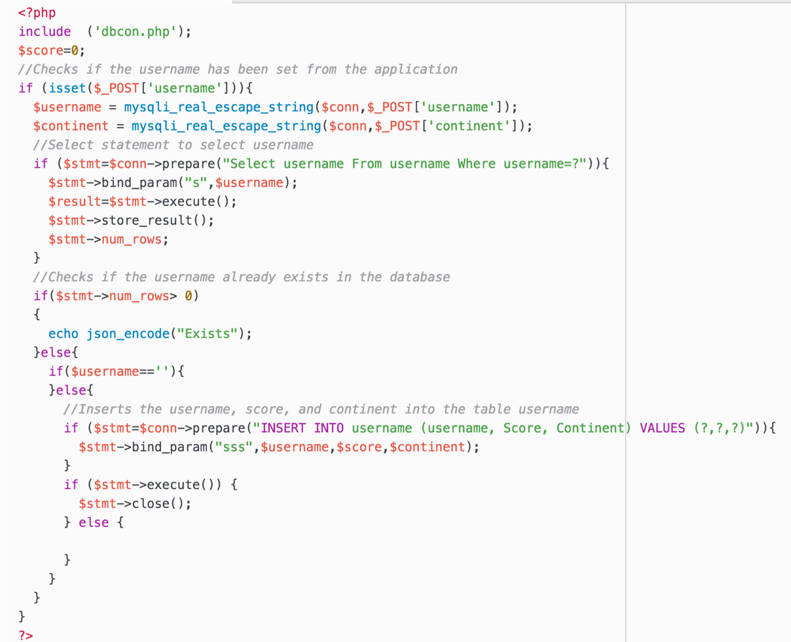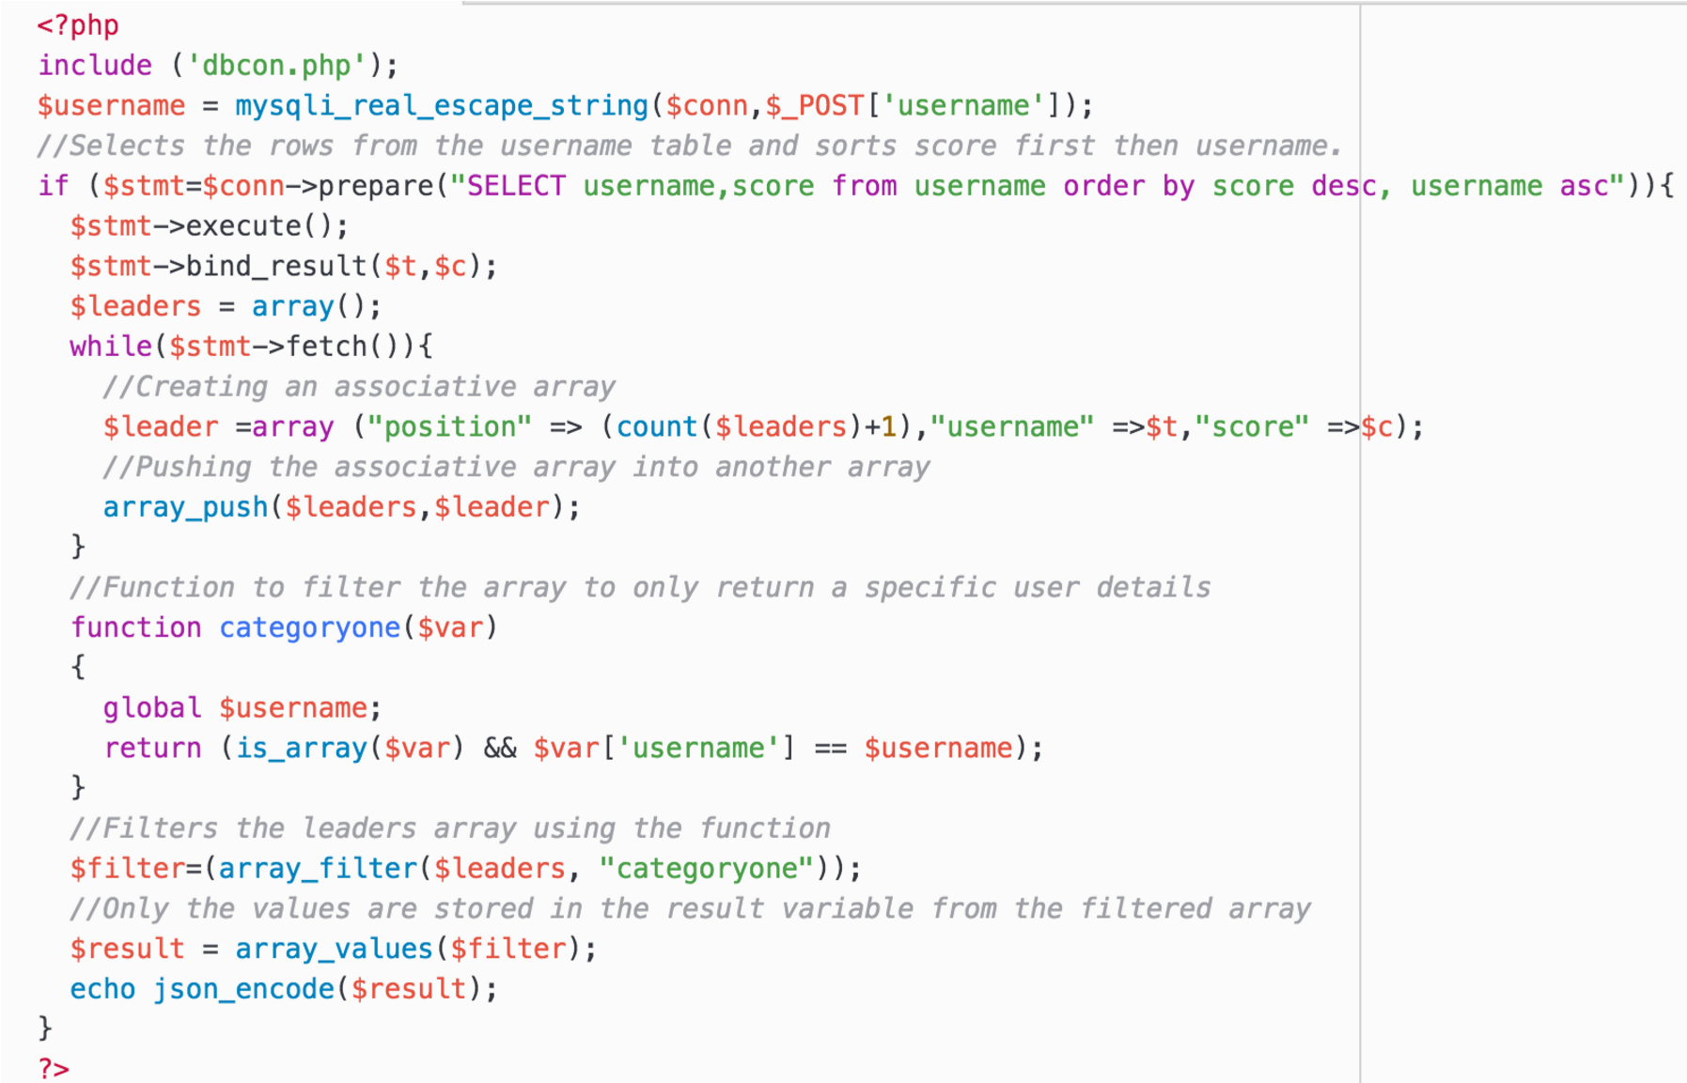

‘Updating Achievement’s Progress’

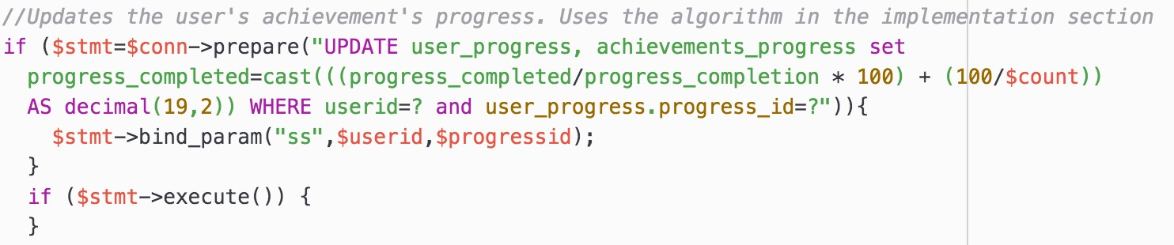

‘Checking achievement’s progress’

‘Adding badges to each specific user’

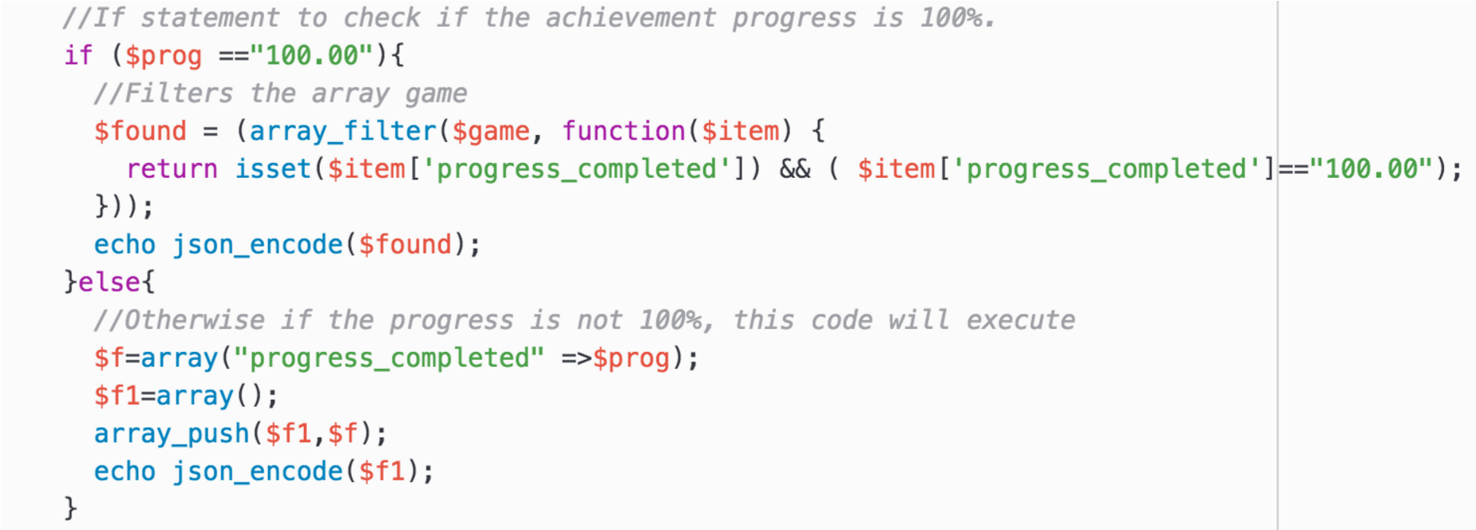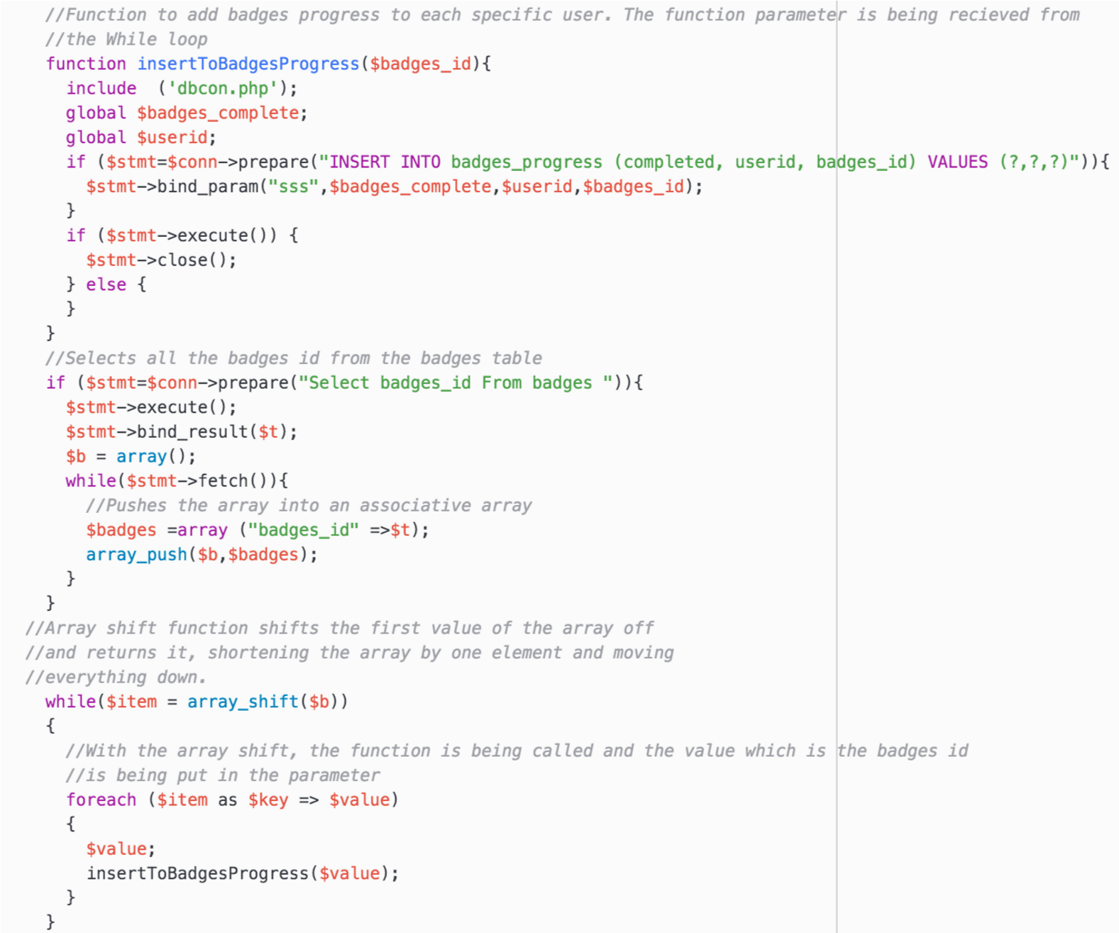

## 11.4 Appendix D - Sample of Android Codes

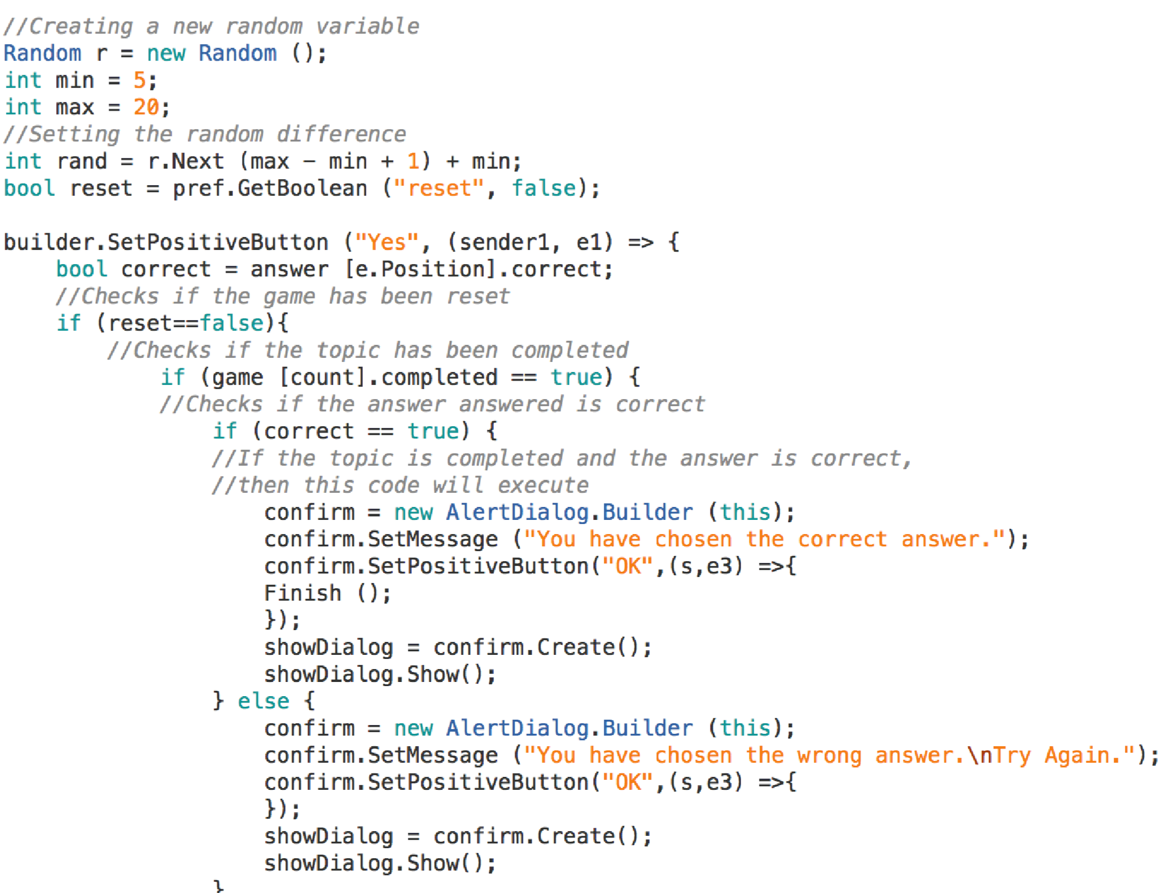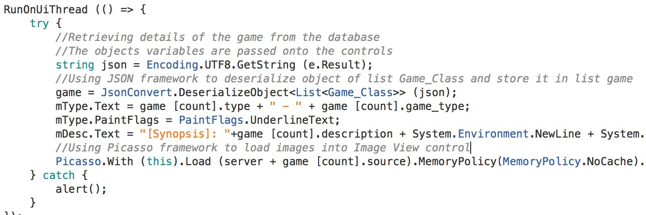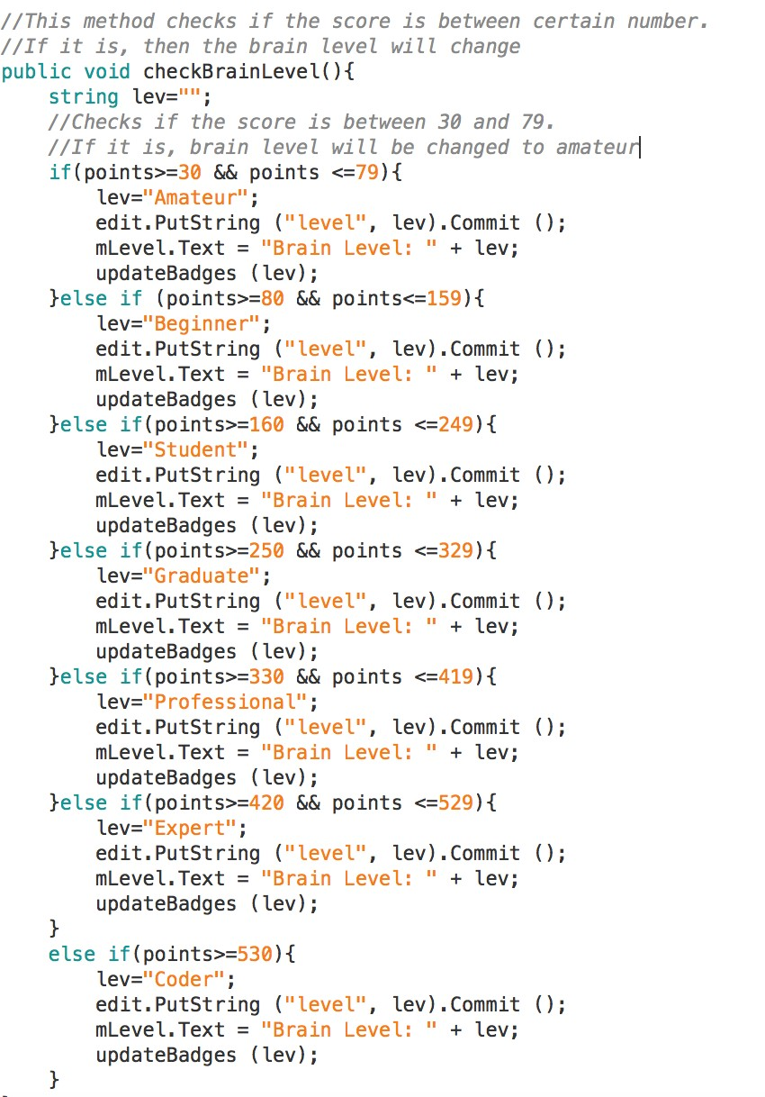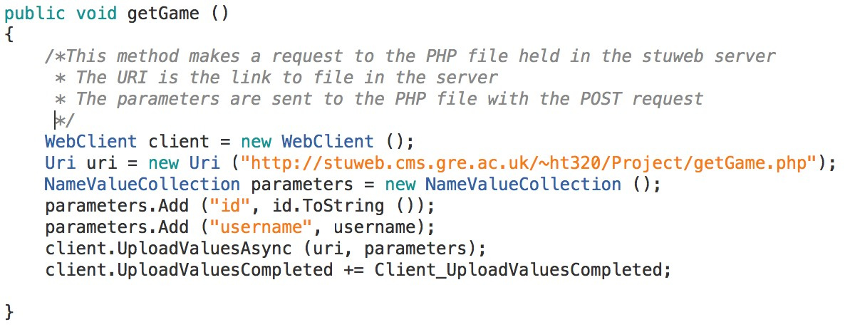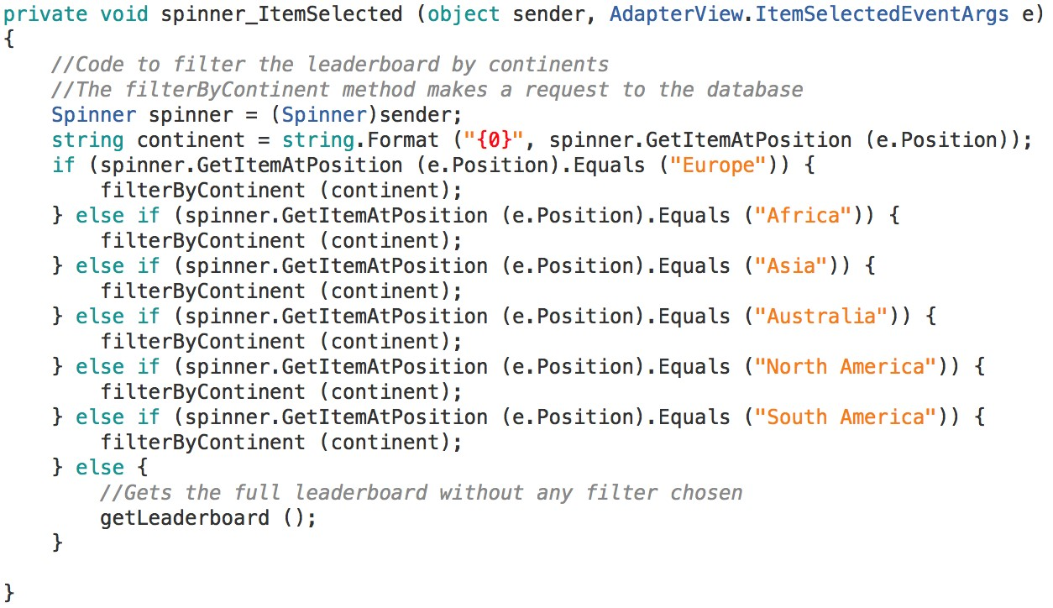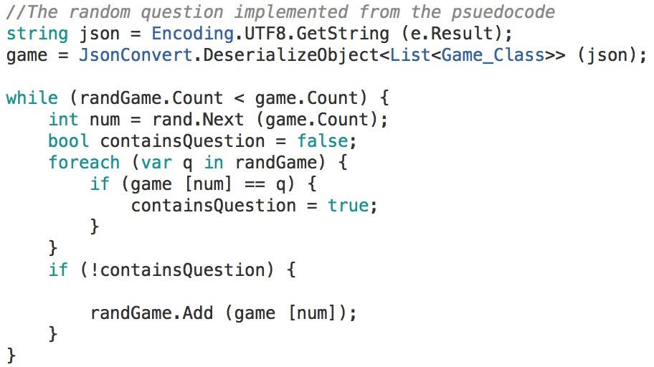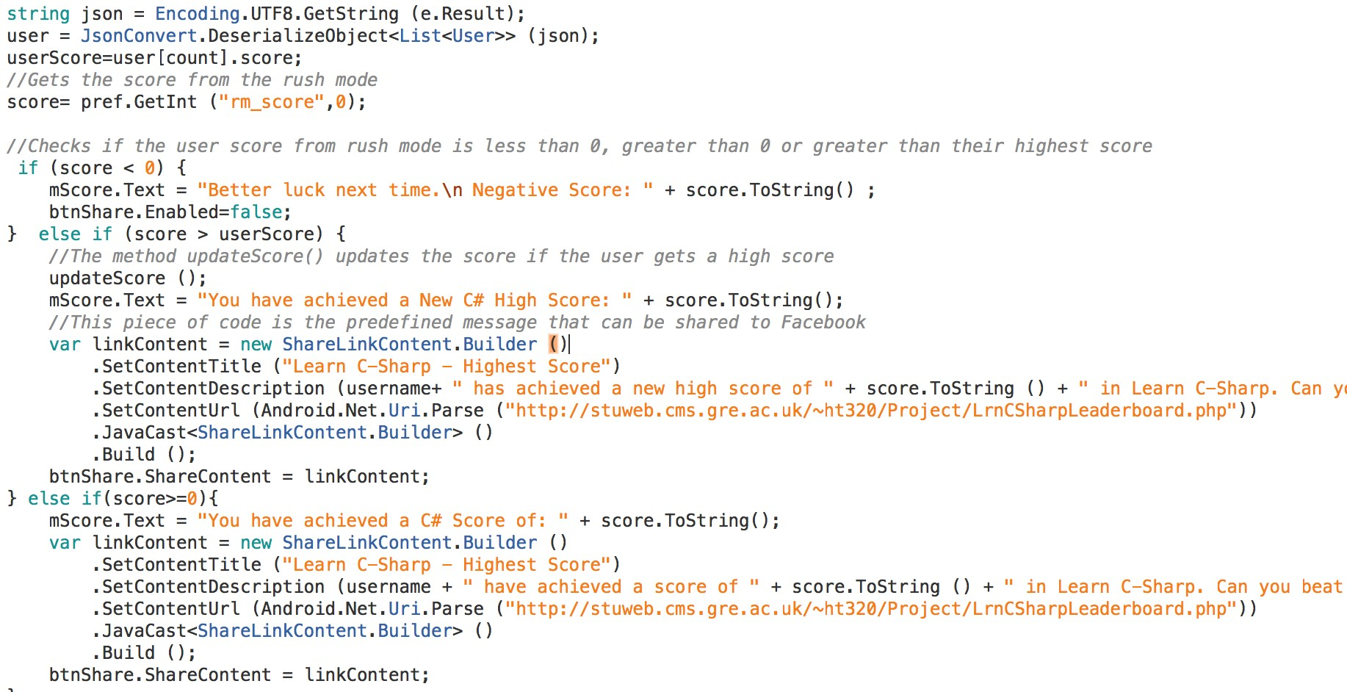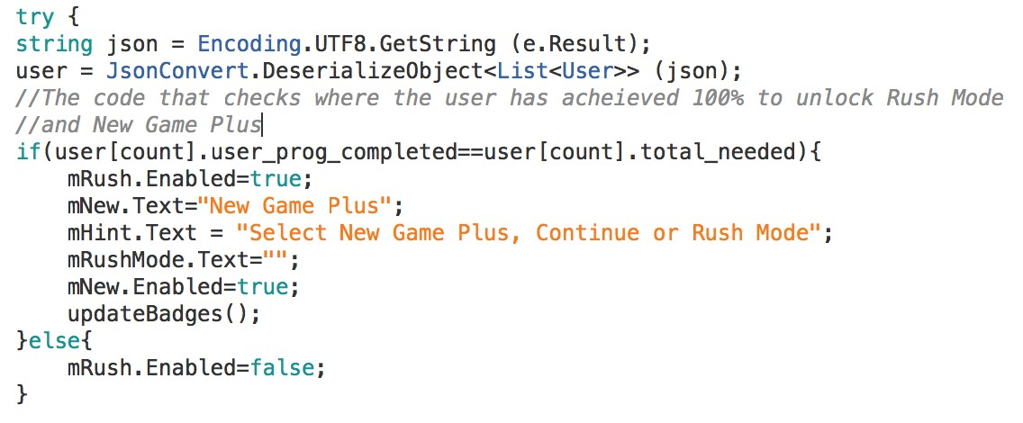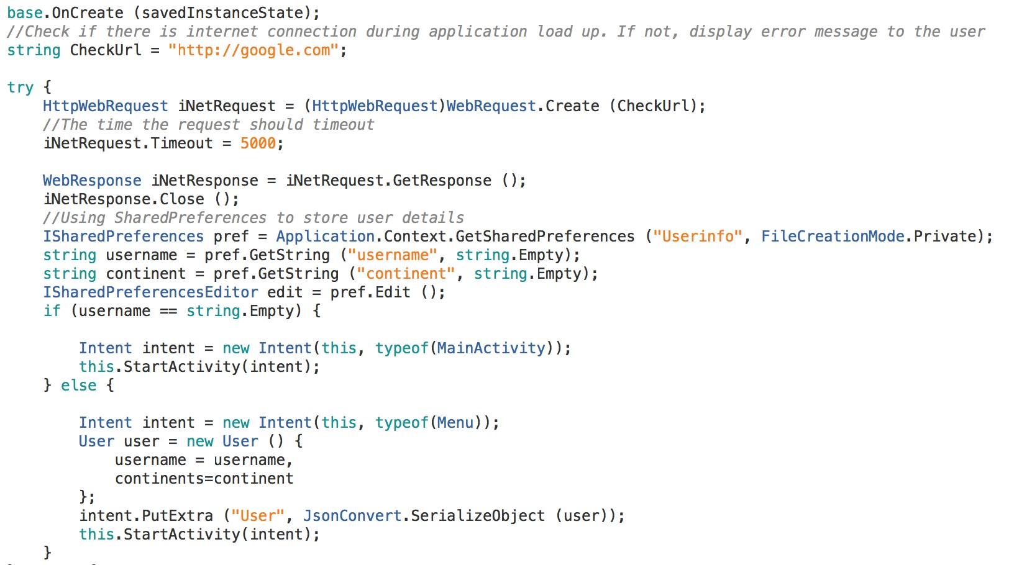

## 11.5 Appendix E –Android Application Test Plan

|  |  |  |  |  |  |
| --- | --- | --- | --- | --- | --- |
|  |  | Prototype One | |  |  |
| Test  Number | Test Description | Expected  Outcome | Actual Outcome | Achieved? | Action Taken |
| 1 | Checking if the application is communicating with the database | The list view should populate automatically from the database | The list view has populated from the database automatically | No | Action Note 1 |
| 2 | Checking if the list view is created during runtime | The list view should be displayed during runtime | The list view has been displayed during runtime | Yes | None |

Action Note 1 – The application failed to communicate with the database, so an action has to be taken. Upon closer inspection, the web client had the wrong URI link to the PHP file and caused the communication to fail. The URI was amended and the test was retaken, this time populating the list view from the database automatically. As of now, the test has seemed to pass.

|  |  |  |  |  |  |
| --- | --- | --- | --- | --- | --- |
|  |  | Prototype Two | |  |  |
| Test  Number | Test Description | Expected  Outcome | Actual Outcome | Achieved? | Action Taken |
| 1 | Checking if the Facebook API has been successfully implemented | From the  Facebook  Developer Centre website, there should be a graph that would indicate it has been implemented | The graph is shown on the website and indicates it has been implemented | Yes | None |
| 2 | Checking if the user can log into  Facebook | The user should be able to log into their Facebook account | The user has logged in to their Facebook account | Yes | None |
| 3 | Checking if the user can share predefined message to Facebook | The user should be able to share a predefined post | The post has been shared to  Facebook | Yes | None |
| 4 | Checking if the user can log out from Facebook once they signed in | The user should be able to log out whenever they desire | The user has logged out from  Facebook | Yes | None |
| 5 | Store user details in Shared Preferences | User details should be stored in Shared Preferences | The details have been stored | Yes | None |
| 6 | Retrieving stored user details from Shared Preferences | The user details should be retrieved and shown on the console | The user details have been shown on the console | Yes | None |

|  |  |  |  |  |  |
| --- | --- | --- | --- | --- | --- |
|  |  | Prototype Three | |  |  |
| Test  Number | Test Description | Expected  Outcome | Actual Outcome | Achieved? | Action Taken |
| 1 | Browse Chapters | The details should be obtained from the database and the user should be able to browse chapters | The details have been obtained from the database and the chapters can be browsed | Yes | None |
| 2 | Browse Topics | The details should be obtained from the database and the user should be able to browse topics | The details have been obtained from the database and the topics can be browsed | Yes | None |

|  |  |  |  |  |  |
| --- | --- | --- | --- | --- | --- |
| 3 | Checking to see whether the topics are completed or not | The user should be able to the topics that have been completed and not completed | The completed and noncompleted topics were shown | Yes | None |
| 4 | View game content after clicking a topic | The user should be able to see the game content coming from the database | The game content has been shown | Yes | None |
| 5 | View  Achievements  Progress | The achievements progress for the user should show | The achievements progress for the user has been shown | Yes | None |
| 6 | View Badges  Progress | The badges progress for the user should show | The badges progress for the user has been shown | Yes | None |
| 7 | Continue Game once a new game has started | The Continue button should be enabled and new game should be disabled | Continue button has been enabled and new game button has been disabled | Yes | None |
| 8 | Show user’s current overall progress in main  menu | The overall user’s current progress should be shown in the main menu | The progress of the user has been shown | Yes | None |
| 9 | Keep New Game  Plus and Rush Mode until 100% progress is achieved | The New Game  Plus and Rush Mode should be locked until 100% progress is achieved | The buttons stayed locked until 100% was achieved, they unlocked | Yes | None |
| 10 | Play rush mode | The user should be able to play rush mode | The user has played the rush  mode | Yes | None |
| 11 | Share score and a | The user should | The post has | Yes |  |

|  |  |  |  |  |  |
| --- | --- | --- | --- | --- | --- |
|  | written post to  Facebook | be able to share their score with a written text accompanied with  it | been shared with their score and their written text |  | None |
| 12 | Reconfirm user’s choice of answer | The user should be notified and reconfirm the choice of answer | The user has been notified | Yes | None |
| 13 | Increment score | The score should increment when the user gets an answer correct | The score has incremented | Yes | None |
| 14 | Randomly decrement score with a random number | The score should randomly decrement when the user gets an answer wrong | The score has randomly decremented | Yes | None |
| 15 | Decrement timer by a second | The timer should decrement automatically by a second in rush mode | The timer decremented by a second automatically | Yes | None |
| 17 | Randomly increment timer with a random time | The timer should be incremented randomly when a user gets a answer correct in rush mode | The timer has randomly incremented | Yes | None |
| 18 | Increment life by 1 with a given probability that it would | If the probability of getting a life is true, then the life should increment by 1 when a user gets the answer correct. If not, then life should not increment | The life has been incremented by  1    Alternate Event: Life was not changed. Stayed the same. | Yes | None |

|  |  |  |  |  |  |
| --- | --- | --- | --- | --- | --- |
|  |  |  |  |  |  |
| 19 | Decrement life by  1 | The life should be decremented by 1 when a user gets a answer wrong | The life has decremented by  1 | Yes | None |
| 20 | View questions randomly in rush mode | The questions in rush mode should be randomly displayed in every time | The questions are randomly displayed | Yes | None |
| 21 | View weekly progress in a graph | The graph should show the weekly progress of the user | Failed to show the graph | No | Action Note 2 |
| 22 | Register username and continent upon first launch of the app | The user should be able to register their details | The user has registered their details | Yes | None |
| 23 | Use a splash screen to determine if a user has registered or not | Upon launch of the app, the splash screen should determine if the user has registered. If registered, show main menu. If not registered, show the registration screen | The main menu has been launched after the splash screen    Alternate event: Registration screen has been launched after the splash screen | Yes | None |
| 24 | View user’s detail in main menu screen | The details of the user should be shown on the main menu | The details have been shown | Yes | None |
| 25 | Check if all the buttons are | The buttons found in the main menu | The button are all working | Yes | None |
|  | working | should be all working |  |  |  |
| 26 | Check if the sliding tabs are working and displaying content correctly | The tabs should move from achievements to badges and vice versa and display content according to what tab is selected | The tabs can be selected and each tab displayed their respective contents | Yes | None |
| 27 | Show the leader oar for every top  50 users | The leader board should show the top 50 users | The top 50 users are shown | Yes | None |
| 28 | Show the position and score of the specific user | Display the leader board position and scores of the specific user owning the android device | The position and scores have been displayed | Yes | None |
| 29 | Filter the leader board according to continent | The leader board should be filtered according to the continents | The leader board has been  filtered | Yes | None |
| 30 | Updating brain level according to score | Brain level should be updated according to the score gained | Brain level has been updated | Yes | None |

Action Note 2 – The graph was implemented but failed to show the results on the graph. It was unable to get the data from the database. Due to time constraint, the graph requirement was left out and taken out from the application.

|  |  |  |  |  |  |
| --- | --- | --- | --- | --- | --- |
|  |  | Prototype Four | |  |  |
| Test  Number | Test Description | Expected  Outcome | Actual Outcome | Achieved? | Action Taken |
| 1 | Handling any database errors | Any errors related to the database | The messages are displayed to | Yes | None |
|  |  | should be handled and a message should be displayed | the user |  |  |
| 2 | Handling any application errors | Any errors related to the application should be handled and a message should be displayed | The messages are displayed to the user | Yes | None |
| 3 | Use splash screen to determine if there is any internet connection | The splash screen should make a request to Google to check if there’s internet connection | The request has been made | Yes | None |
| 4 | Display message when there is no internet connectivity | The user be notified when there is no internet connection | The user has been notified | Yes | None |
| 4 | Handle internet connection error during the middle of gameplay | The user should be notified during gameplay when they have lost their internet connection | The user is sometimes notified but mostly it fails to notify the user and leaves the screen as blank | No | Action Note 3 |
| 5 | Validation rule for when registering | When the username text field is empty or already taken, it should notify the user | The user has been notified | Yes | None |

Action Note 3 – The errors are handled when there is no internet connection during the middle of gameplay but the message is displayed to the user sometimes. Most of the time it would fail to show and just leave the screen as being blank thus making the user wait for a long time for a response action. There may have been a bug with the coding that needs checking into and could be a potential solution.

## 11.6 Appendix F- PHP Web Service/ MySQL Database Test Plan

|  |  |  |  |  |  |
| --- | --- | --- | --- | --- | --- |
| Prototype Two | | | | |  |
| Test  Number | Test Description | Expected  Outcome | Actual Outcome | Achieved? | Action Taken |
| 1 | Inserting user’s details | The user’s details should be saved in the database | The details have been saved | Yes | None |
| 2 | Adding achievements progress for each user upon first launch of app | Upon first launch of the app, achievements progress for the user should be added after registering | Achievements progress has been added to the database | Yes | None |
| 3 | Adding badges progress for each user upon first launch of app | Upon first launch of the app, badges progress for the user should be added after registering | Badges progress has been added to the database | Yes | None |
| 4 | Updating achievements progress | The achievements progress should be updated whenever a specific user completes a topic | The achievements progress for the specific user has been updated | Yes | None |
| 5 | Updating badges progress whenever a specific user obtains a brain level or completes the whole game | The badges progress should be updated for the specific user | The badges progress for the specific user has been updated | Yes | None |
| 6 | Updating user’s score when getting | The score should only be updated | The score has been updated | Yes | None |
|  | a high score | whenever the user gets a high score |  |  |  |
| 7 | Stop updating achievements progress when a particular achievement is  100% | The achievements progress should stop updating when a particular achievement is  100% | The achievement progress has stopped updating | Yes | None |
| 8 | Start New Game Plus and reset the game only if 100% user progress is achieved | The option to start a New Game Plus should only be allowed when 100% user progress is achieved. Upon starting a new game plus, the game data should  reset | New Game Plus has been unlocked and the game data has been reset | Yes | None |

## 11.7 Appendix G - Statement of Requirements Evaluation

Below are the functional, non-functional and additional requirements and a statement for each saying whether they have been met or not.

#### Functional Requirements

1. Must register user details upon launching the application for the first time. Subsequent launches of the app should not ask for registration.

-This requirement has been met as the application only askes for registration during first time launch of the app.

1. Must allow the user to browse and choose which chapters to tackle first
   * This requirement has been met as the application allows the user to browse the chapters and choose any chapters to be tackled first

1. Must allow users to browse and choose which topics in each chapter to tackle first
   * This requirement has been met as the application allows the user to browse the topics within a chapter and allows the user to choose any topic to be tacked first

1. Must keep track of scores during the teaching phase to keep users engaged and motivated and update score whenever necessary
   * This requirement has been met as the application keeps track of the scores during the normal game mode and rush mode

1. Must keep track of user’s progress and keep note of it
   * This requirement has been met as the application keeps the track of the user’s progress in the main screen

1. Must have an achievements page implemented, with the data being received from MySQL database, to allow the user to see their achievements progress

-This requirement has been met as the application allows the user to see their achievements progress

1. Should have the ability for the user to log into their Facebook account with the FB API

-This requirement has been met as the application allows the user to log in to their Facebook account from the main menu screen

1. Should have the ability for the user to log out from their FB database whenever they desire without any restriction (It’s a MUST if the above requirement is implemented)
   * This requirement has been met as the application allows the user to log out from their Facebook account from the main menu screen

1. Should have a rush mode implemented where all exercises are given at once to complete within a set time limit
   * This requirement has been met as the application allows for the user to play the rush mode game given that they have achieved 100% progress

1. Should have the ability for the user to share their game experience and score to Facebook
   * This requirement has been met as the application allows the user to share their score to Facebook

1. Should have a leader board implemented, with the data being received from the MySQL RDBMS database, to allow the user to see who is at the top and what position the current user is in
   * This requirement has been met as the application allows the user to see the leader board from the main menu screen

1. Should have a badges page implemented, with the data being received from the MySQL Database, to allow the user to see their badges progress - This requirement has been met as the application

1. Could have a tutorial page explaining how the app should be used, and how the app functions
   * This requirement has been met as the application allows the user to see the tutorial page from the main menu screen and give information to the user about the application

1. Could have a graph to show the weekly progress similar to Nike + Fuel app
   * This requirement has not been met as the graph failed to retrieve the data from the database and plot the points. This requirement was then left out due to time constraints and was taken out from the application. Since this had a COULD priority, it was not that important

#### Non Functional Requirements

1. Usability – The application should have an easy to use interface with the pages being kept as simple as possible. The user should understand the flow of the design with having consistent layout and navigate around with ease.

-This requirement has been met as the user interface has been kept simple and effective

1. Accessibility – The application should be accessible by anyone without any restrictions for example, those people with disabilities. In terms of colour, simple colours should be used and the colour scheme must be maintained throughout the application.

-This requirement has been partly met as the user interface is accessible by most people. Simple colours may have been used but for those who are colour blind, they have not been taken into consideration

1. Reliability – The application should be able to perform its required tasks under stated conditions in a specific time period.

-This requirement has been met as the application performs the task in a minimum time possible

1. Fault tolerance – The application should be able to continue operating normally, possibly at a reduced level, when one or more of its components fails.

-This requirement has been met as the program still continues working when one or more components fail. But if there is no internet connection, then the program may not work and the user will be notified.

1. Performance – The application should have a fast response time during the user usage of the application.

To reduce load time, images will be cached to the system memory and loaded back from the memory.

-This requirement has been met as the Picasso framework takes care of this problem

#### Additional Requirements

1. Must have a reading/writing style learning where the users will read a certain text and will answer questions according to that

-This requirement has been met as it allows the user to read certain content and answer question based on that

1. Should have as visual style learning where images of codes will be displayed and then disappear after a while. User will have to guess the correct image shown -This requirement has not been met due to time constraints

1. Could have an auditory style learning where users are required to remember words in relation to C# and would increase in difficulty each time it is correct

-This requirement has not been met due to time constraints and unable to implement auditory features

## 11.8 Appendix H - Project Proposal

**COMP1682 Project Proposal**

#### **Developing an android application teaching students to program with the use of gamification as an incentive**

Taffazzal Hussain

BSc Computer Science

000771198

#### **1 Overview**

Learning is the key fundamental process that everyone needs to endure in their lifetime. Without learning, people will not be able to adapt and bear. Learning is the key to achieving a person's full potential and human beings are uniquely adapted to learn and can learn throughout their lifespan. Learning does not happen through isolation, and there are many factors that can either boost learning or hinder learning. A person's motivation and their preferred learning style can be a help to their ability to learn.

This project will explore how the ways and motivation can help people learn better with the use of gamification techniques in order to create an android gaming app as a stimulus. At the moment, there are few apps in the PlayStore which offer an insight into learning programming with little or no gamification techniques involved. However, they are not aiming at the target audience which Hussain is intending to aim at, which are the Key Stage 4 students, college and university users. In addition, some of the apps are not open source which may dis-courage people into using them.

Some people can learn visually and some people can learn with audibility, and some can learn with virtual interactivity. The few current apps in the stores may have virtual interactivity in them but the apps themselves are not open source. To solve this, a app needs to be created in order to challenge the existing ones and improve further so it exceeds the current ones in creativity and productivity.

Keywords: Android, Xamarin, Gamification, Learning

#### **2 Scope of Project**

The proposed product will solve this issue by implementing an open-source android gaming application that will have gamification techniques implemented in order to make the users learn more about programming. There will be various gaming methods e.g. choosing the correct For Loop with a given scenario, in order to keep the users engaged and not become bored of just playing a static game. Gamification techniques such as achievements, levels etc. will be a big feature of this application, as this will help the users to be engaged.

The achievements that is obtained can be posted to social network such as Facebook, Twitter to show to their friends/followers. In doing so, this app could be promoted to other users and they can see what it is all about.

#### **3 Aims and objectives**

**3.1 Aim**

To explore the ways of how gamification can be a motivation to learning in order to create an android mobile gaming application that will allow users to learn how to program in C# and Java.

**3.2 Objectives**

Research Report [25.5]

3.2.1 Conduct a literature review on gamification and learning

* Find journal papers and relevant literature on gamification techniques that are used to motivate learning [14.0]
* Produce a literature review evaluating the topic [5.0]
* Conduct a technical review [3.0]
* Research current applications with those having gamification in Play Store [1.5]
* Test and evaluate a sample of these apps. Write the findings as a review [2.0]

Design Documentation [14.0]

3.2.2 Produce a series of design documentations that will be needed for this project e.g. Statement of Requirements

* List all the key functional and non-functional requirements according to the MoSCoW rule [2.0]
* Create an Entity Relation Diagram sketch with the necessary tables and normalizing tables in 3rd form [2.0]
* Create UML diagrams for application e.g. Use cases for how the user will interact with the application [5.0]
* Design the user interface as a mock up [3.0]
* Create a test plan for system and usability [2.0]

Product Implementation [22.0]

3.2.3 Implementation of the android application

* Gather necessary assets/ produce assets
* Install Xamarin Studio, install JSON.Net library and configure PHP [1.0]
* Create the Android activities (user interfaces using the mock up as a guide) and the required classes [3.0]
* Create the database in MySQL [1.0]
* Populate the tables in database with mock data [1.0]
* Create the actual prototype [16.0]

Testing [6.0]

3.2.4 Application passes all test in the test plan and meets user requirements

* Test the system according to test plan [4.0]
* Review tests [1.0]
* Take actions if necessary [1.0]

Evaluation and Reflection [9.0]

3.2.5 Produce a semi-report to see whether the application passed all test cases and meets user requirements. Reflection will be to see how the process and performance of the project went

* Evaluate the final product against the statement of requirements [3.0]
* Using results from testing, evaluate the application [3.0]
* Reflection of the overall project process including strength and weaknesses [3.0]

#### **4 Approach**

A methodology must be chosen and in place when carrying out a project in relation to IT. Following a methodology will ensure the success of the project as well as being cautious in the stages of the development. For this particular project, the iterative waterfall methodology was selected over other methodologies due to having many benefits. This method allows the probability of revisiting any stages in the development cycle, as many times needed. The problem would arise only when the previous stages are visited many times back and forth and thus having an effect on the limited time that is allocated. Even though this methodology allows the visitation of previous stages, it is crucial to avoid the need to visit various times to ensure the maximum time and effort is used in each stages effectively.

#### **5 Legal, Social, Ethical and Professional**

The first legal consideration that needs to be taken into consideration is the “Data Protection Act (1998)” as users will be asked initially to sign up and provide their details such as name and email and this will be stored in a database. For privacy purposes, the details need to be encrypted for extra security to avoid any unnecessary parties gaining access. Second consideration is the Copyright, Designs and Patents Act (1998) which protects software from being misused in any ways such as copying, modifying or reselling without permission. As this project will primarily use open source software for the development of this project, it should not breach this act either.

The ethical aspect of this project is in regards to testing the application on a set of users with both iOS and Android mobile devices. As the user acceptance testing will be done with fellow colleagues from the university, it will not require ethical approval. As far as professional point of view is concerned, all meetings will be scheduled and all work will be produced to adhere to the academic standards and not plagiarize existing work. In addition, posting achievements to the social networks will may need access to certain contents in order for it to post. The project needs to make sure that personal details from third-party are not held in the application in under any circumstances.

#### **6 Planning (see appendix A)**

The project will be approached in an evolutionary and iterative methods. The reasons are due to the nature of the project as the project, at this stage, is still at the initial phase. The requirements for the project now are not final, and could change in any time during the phase of the project.

The project plan will be taken into consideration in order to make sure that the activities are met. The project will need to be monitored weekly and see how much progress has been made, so that if any adjustments are needed to be made, they can be adjusted for the situation to be best suited. The Gantt Chart *(appendix A)* will show the timeline of each stages that needs to be completed in order to stay in schedule and meet deadlines whenever. During the course of this project, some elements mentioned in the Gantt Chart may change due to the nature of the project.

#### **7 Initial References**

Data Protection (May 2014) *Protecting personal data in online services* [Online – PDF] Available from: https://ico.org.uk/media/for-organisations/documents/1042221/protecting- personal-data-in-online-serviceslearning-from-the-mistakes-of-others.pdf [Accessed: 19/10/2015]

Legislation.gov.uk (1990) *Computer Misuse Act 1990* [Online - Website] Available from: http://www.legislation.gov.uk/ukpga/1990/18/section/1 [Accessed: 19/10/2015] iTunes Preview (2015) *C++ Programming Language* [Online – Store] Available from: https://itunes.apple.com/us/app/c++programming- language/id461327665?mt=8 [Accessed: 20/10/2015]

Xamarin *Building an iOS Game with Cocos2D-XNA* [Online] Available from:

https://developer.xamarin.com/guides/cross-platform/cocos2d_xna/cocos2dxna_tutorial/ [Accessed: 04/11/2015]

Xamarin *Building Cross Platform Application* [Online] Available from: https://developer.xamarin.com/guides/cross-

platform/application_fundamentals/building_cross_platform_applications/ [Accessed: 04/11/2015]

Journal of Computer Assisted Learning (1987) 3, 67-80 (1987) *Ways of learning in a computer based environment: some findings of the Logo Math’s Project by C. Hoyles, R. Sutherland, Institute of Education, University of London* [Online - Journal] Accessed from: http://www.readcube.com/articles/10.1111%2Fj.1365-

2729.1987.tb00312.x?r3_referer=wol&tracking_action=preview_click&show_checkout=1&purc hase_referrer=onlinelibrary.wiley.com&purchase_site_license [Accessed: 21/10/2015]

E-Learning Heroes *Gamification Techniques: How to Apply Them to E-Learning* [Online] Available from:

https://community.articulate.com/articles/gamification-techniques-how-to- apply-them-to-e-learning [Accessed: 06/11/2015]

**Appendix A - Schedule of Work**

**Overview**

Below you can see the overview of the schedule of work for the project.

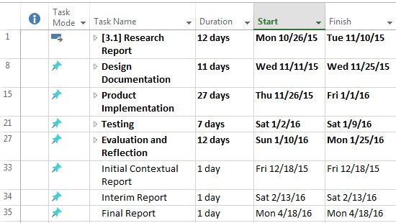

*Figure 1)*

*From the start of the project to the finish of the project*

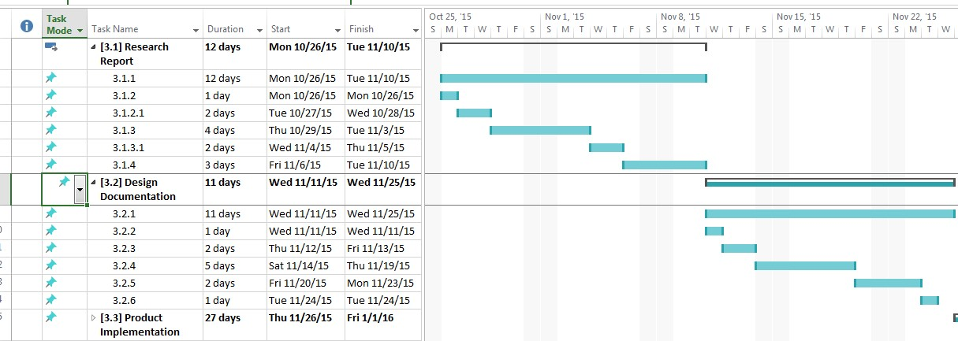

*Figure 2) First half*

*of the Gantt Chart*

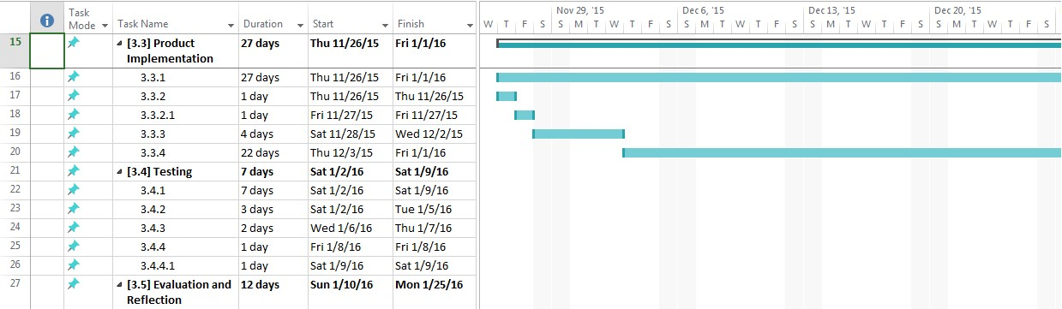

*Figure 3) Second half of the Gantt Chart*

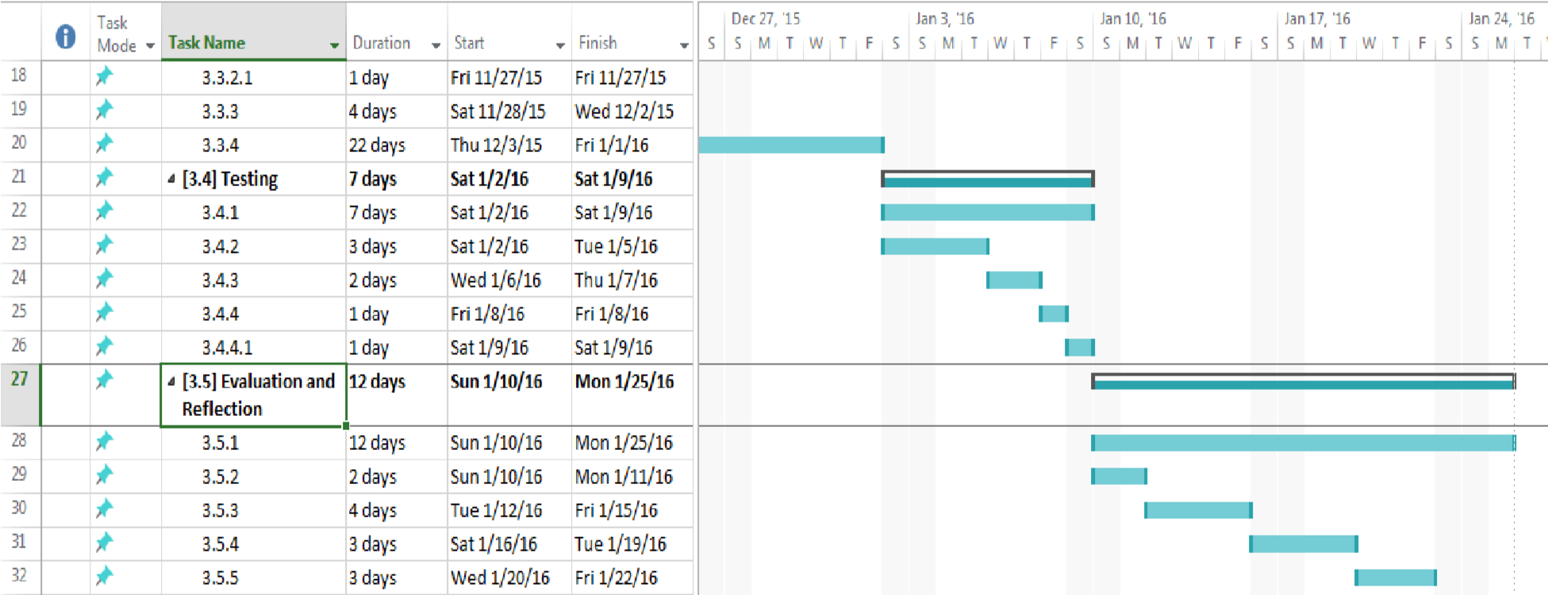

*Figure 4) Third half of the Gantt Chart*